In this worksheet, you will use what you already know about forces and momentum to analyze a series of collisions between objects. As you do so, you will be building towards a rule for the relationship between forces and momentum. Use the box below to keep track of your ideas as you go.
Model-building box: forces and momentum

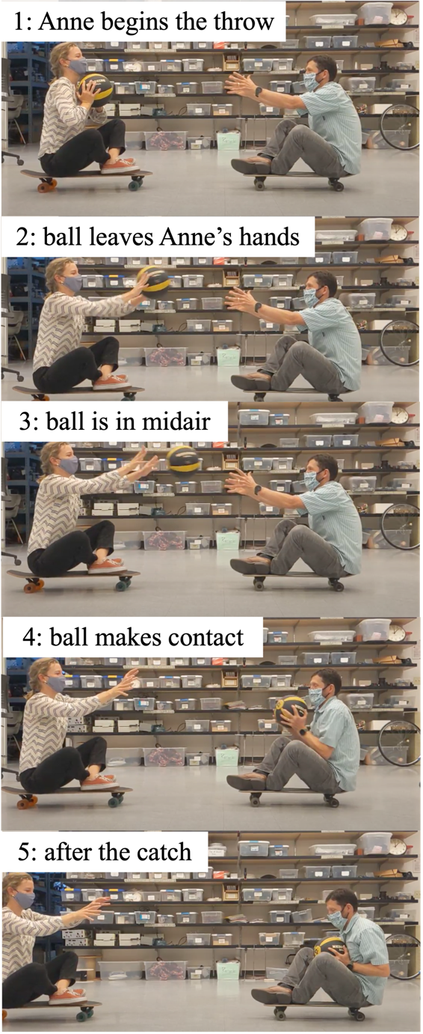
Everyday collisions

Two physicists, Anne and Brady, are facing one another while sitting at rest on two longboards that have very low-friction bearings. Anne tosses a large, heavy ball to Brady, as shown in the series of pictures at right.

Anne begins to move in the direction opposite the ball’s motion.
        - Explain this observation in terms of momentum, including a diagram showing the momentum of each object at two relevant instants.

Momentum diagram for _______at instant ____
Momentum diagram for _______at instant ____
Momentum diagram for _______at instant ____
Momentum diagram for _______at instant ____

        - Explain this observation in terms of forces, including a force diagram at the relevant instant(s). These need not be the same instants you chose in part (a).
Force diagram for _________
at instant ___
Force diagram for _________
at instant ___

        - Using the box on the first page of this worksheet, write down preliminary thoughts about the relationship between force and momentum and the behavior of objects in collisions, based on your analysis of this scenario. Anything you have to say about how force and momentum are related is welcome; you need not write an equation. When you have written something down, share your thinking with an instructor, and explain to them how what you wrote down is connected to your thinking about the scenario with Anne?

Brady begins to move in the direction that the ball was originally moving. Both he and the ball move more slowly than the ball was moving just before he caught it.
- Explain this observation in terms of momentum, including diagrams showing the momentum of each object at two relevant instants.

Momentum diagram for _______at instant __
Momentum diagram for _______at instant __
Momentum diagram for _______ at instant __
Momentum diagram for _______ at instant __

- Explain this observation in terms of forces, including a force diagram at the relevant instant(s).

Force diagram for _________
at instant ___
Force diagram for _________
at instant ___
        - Revisit the box on the first page of this worksheet. What does your analysis of Brady’s momentum and the forces on Brady add to your thinking about the relationship between forces and momentum and the behavior of objects in collisions? Write down any additions or revisions in your box.

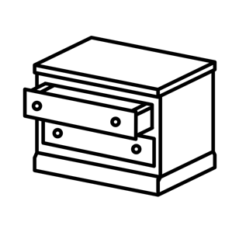
Imagine you want to shut two identical drawers quickly but can’t reach them. You have a rubber bouncy ball and a piece of clay of the same weight. You throw the clay at one drawer and the bouncy ball at the other drawer (with the same speed); the bouncy ball bounces back toward you, whereas the clay ball drops to the ground. You observe that the drawer hit by the bouncy ball shuts faster than the drawer hit by the clay.
      - Explain this observation in terms of momentum, including diagrams showing the momentum of each object at two relevant instants. (It may be helpful to number the instants you’re referring to.)

Momentum diagram for _______at instant __
Momentum diagram for _______at instant __
Momentum diagram for _______ at instant __
Momentum diagram for _______ at instant __

2. Explain this observation in terms of forces, including a free-body diagram at the relevant instant(s).

Force diagram for _________
at instant ___
Force diagram for _________
at instant ___

C. What does your analysis of the bouncy ball/clay ball scenario add to your thinking about the relationship between forces and momentum and the behavior of objects in collisions? Revisit the box on the first page of this worksheet and refine or add to what you have already written there. Discuss what is in your box with an instructor or TA.

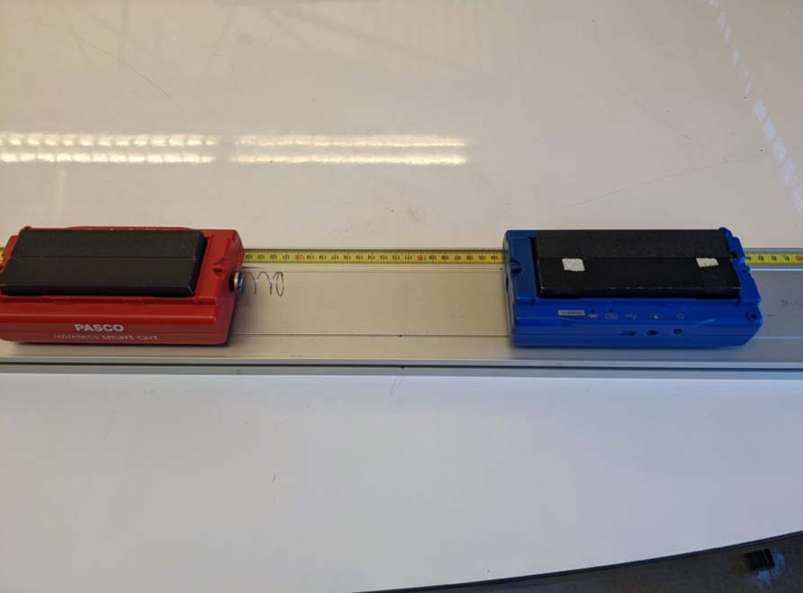
Experiments

1.25 kg
1.25 kg
force sensors
v_{i, blue} = 0.6 m/s
v_{i, red} = 0 m/s
    - Consider the following experiment: A moving cart with mass 1.25 kg collides with a 1.25 kg stationary cart. A stiff spring is attached to the front of the stationary cart and both carts have sensors that record the force by the spring during the collision, as shown in the photo. Below are graphs of each cart’s velocity and the force measured by each sensor over time.

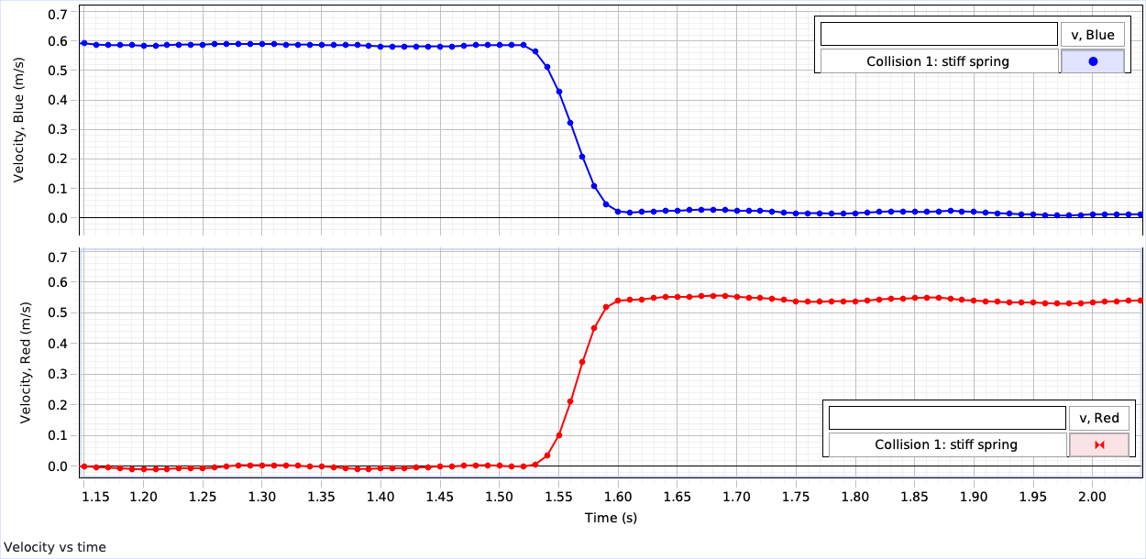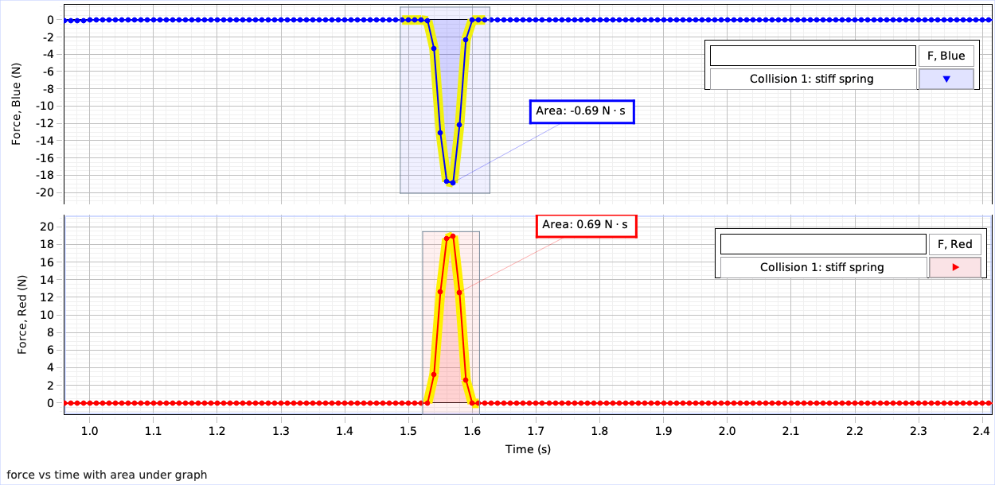
- Coordinate the graphs provided with the experiment, as follows:
      - What does each line in the four different graphs represent?
      - Why do the red and blue graphs mirror one another? How do you make sense of this in terms of the forces being exerted on the carts? Will the red and blue graphs mirror each other in all collisions, or only certain ones?
      - How do you make sense of the change in the velocity graphs that happen shortly after the peaks/troughs of the force graphs?
      - How would you modify the relationship you have been iterating on page 1, based on your analysis of these graphs.

Your instructor has provided you with videos of a number of experiments that measure force and velocity for carts undergoing various collisions. You may also use a simulation to create your own collisions. Choose experiments that will help you to confirm or contradict aspects of the relationship and rules you have written on page 1. Complete the table below for at least three experiments.
Description of experiment 1:

What should happen, based on your rule?

Measurements that verify, disprove, or refine the rule:

Description of experiment 2:

What should happen, based on your rule?

Measurements that verify, disprove, or refine the rule:

Description of experiment 3:

What should happen, based on your rule?

Measurements that verify, disprove, or refine the rule:

Conceptual rule
Revisit the ideas and relationship(s) you’ve written on page 1. Share it with an instructor, and give them an example of at least one experiment that supports your thinking, and one experiment that made you revise your thinking.

