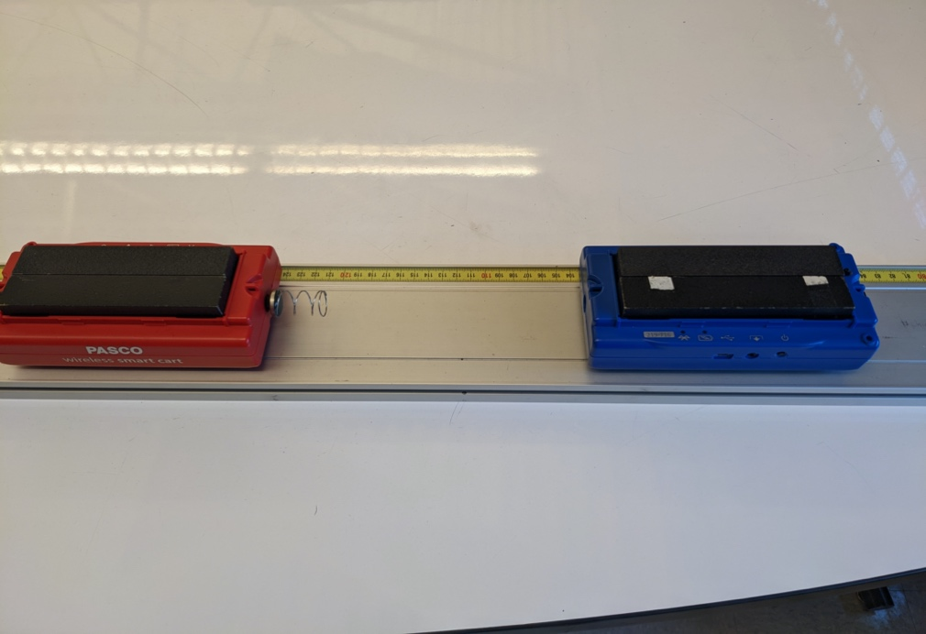
Collision 2: A blue cart is launched with initial speed 0.10 m/s toward a stationary red cart with the same mass. A stiff spring is attached to the front of the stationary cart and both carts have sensors that record the force by the spring during the collision, as shown in the image below.
1.25 kg
1.25 kg
force sensors
v_{i, blue} = 0.10 m/s
v_{i, red} = 0 m/s
The details of the experimental setup are:
Initial speed of blue cart: 0.10 m/s Mass of blue cart: 1.25 kg
Initial speed of red cart: 0 m/s Mass of red cart: 1.25 kg
Attached to force sensor: stiff spring

Below are velocity and force graphs for both carts during this collision.
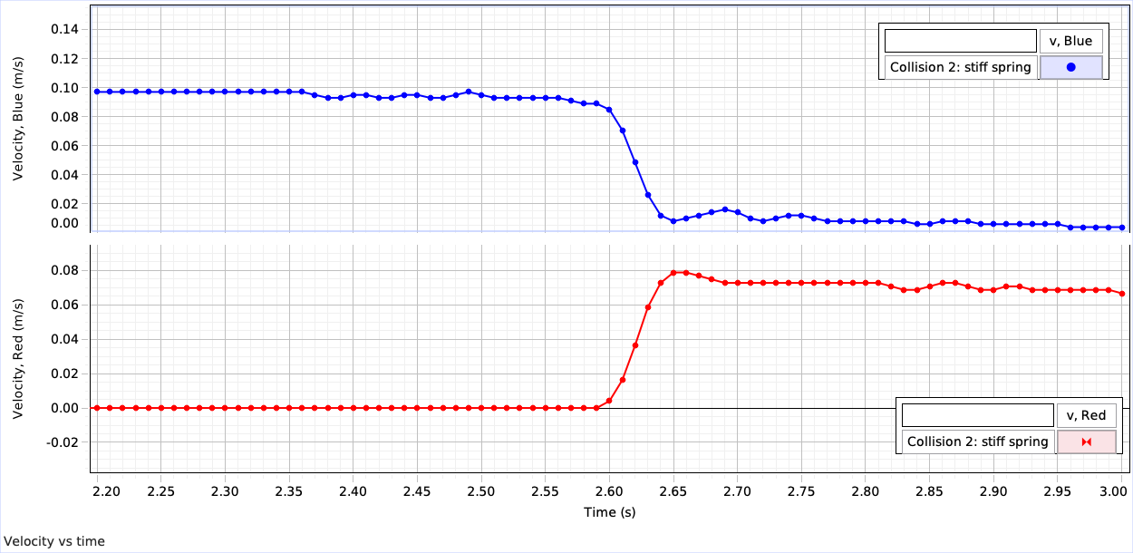
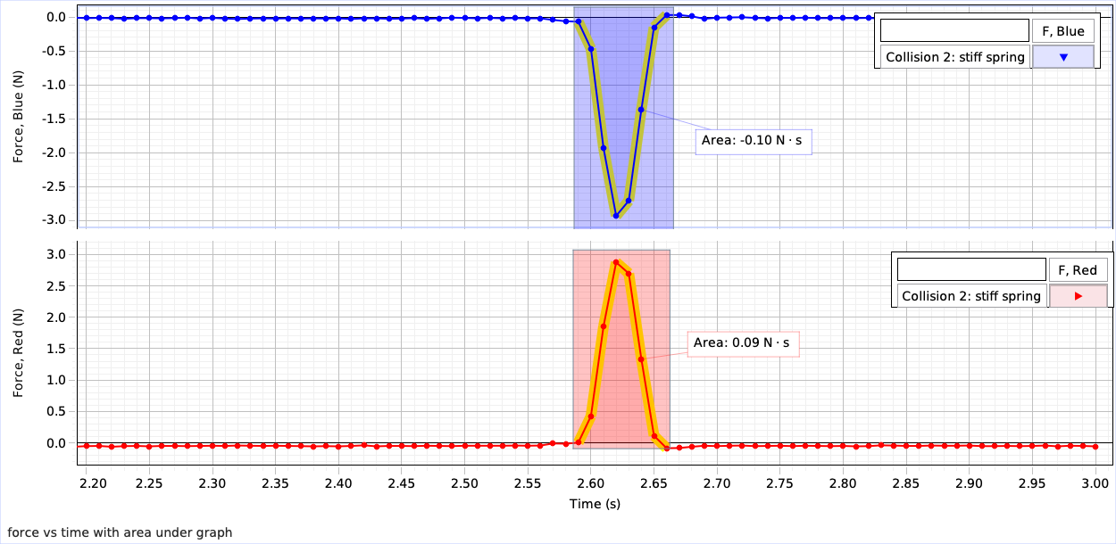
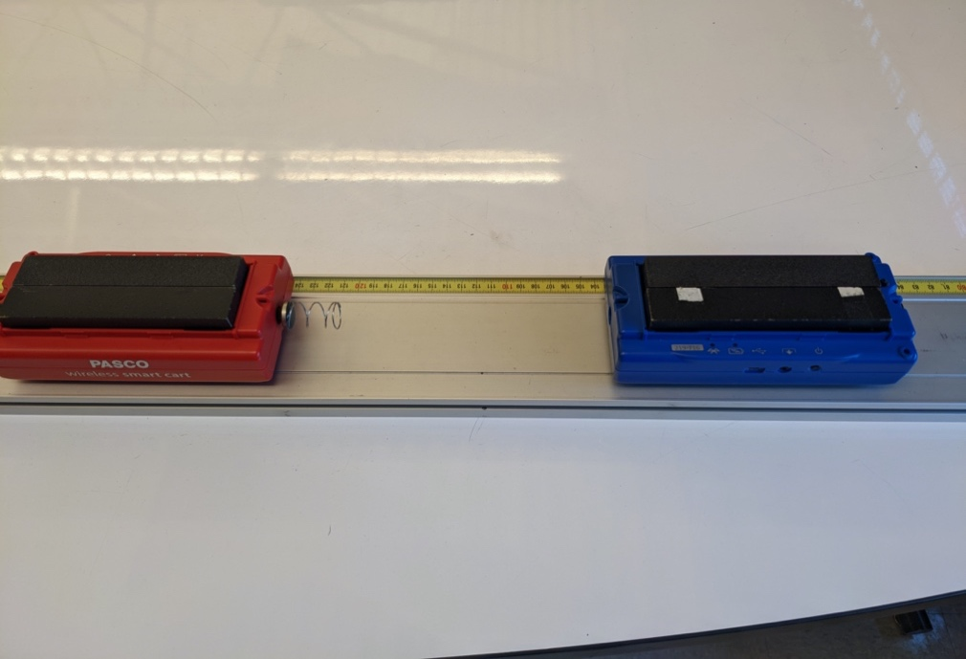
Collision 3: A blue cart is launched with initial speed 0.30 m/s toward a stationary red cart with the same mass. A stiff spring is attached to the front of the stationary cart and both carts have sensors that record the force by the spring during the collision, as shown in the image below.
1.25 kg
1.25 kg
force sensors
v_{i, blue} = 0.30 m/s
v_{i, red} = 0 m/s
The experimental setup is as follows:
Initial speed of blue cart: 0.30 m/s Mass of blue cart: 1.25 kg
Initial speed of red cart: 0 m/s Mass of red cart: 1.25 kg
Attached to force sensor: stiff spring

Below are velocity and force graphs for both carts during this collision.
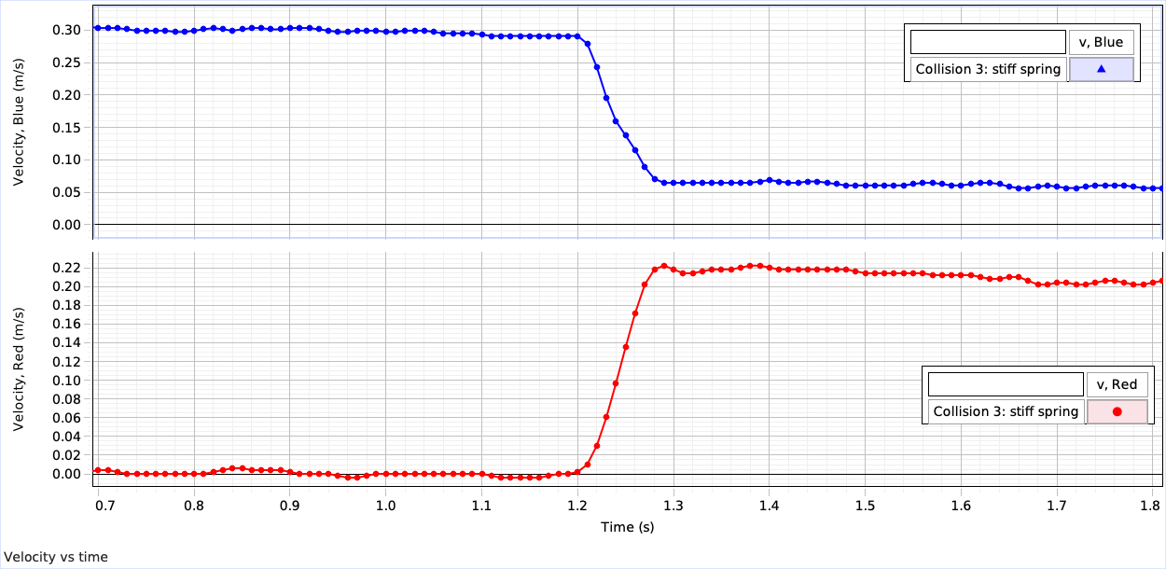
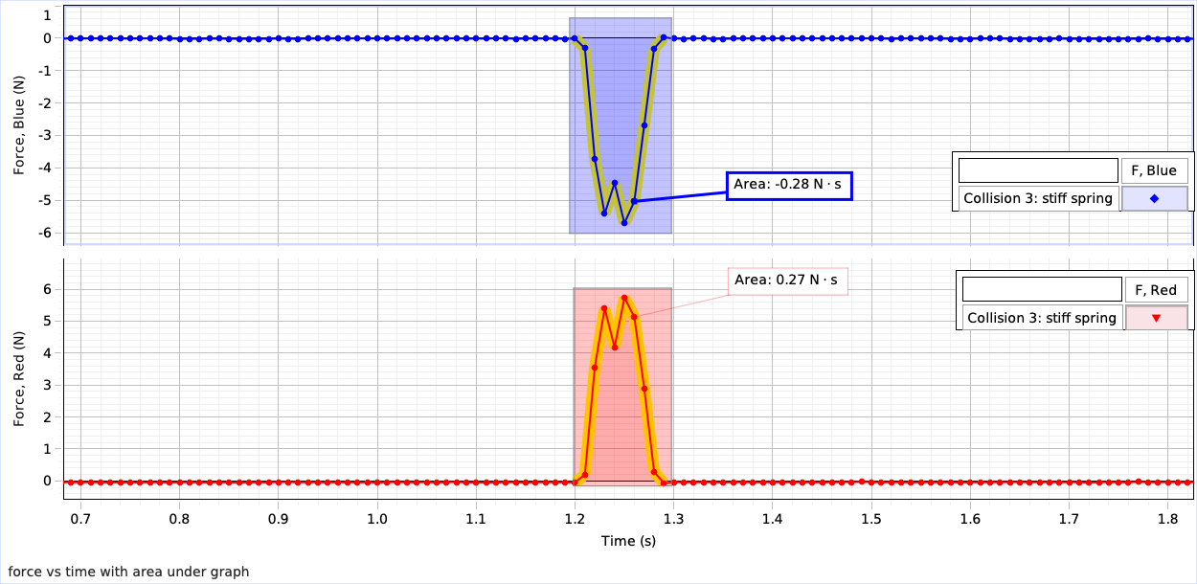
Collision 4: A blue cart is launched with initial speed 0.60 m/s toward a stationary red cart with the same mass. A soft spring is attached to the front of the stationary cart and both carts have sensors that record the force by the spring during the collision, as shown in the image below.
1.25 kg
1.25 kg
force sensors
v_{i, blue} = 0.60 m/s
v_{i, red} = 0 m/s
The experimental setup is as follows:
Initial speed of blue cart: 0.60 m/s Mass of blue cart: 1.25 kg
Initial speed of red cart: 0 m/s Mass of red cart: 1.25 kg
Attached to force sensor: soft spring

Below are velocity and force graphs for both carts during this collision.
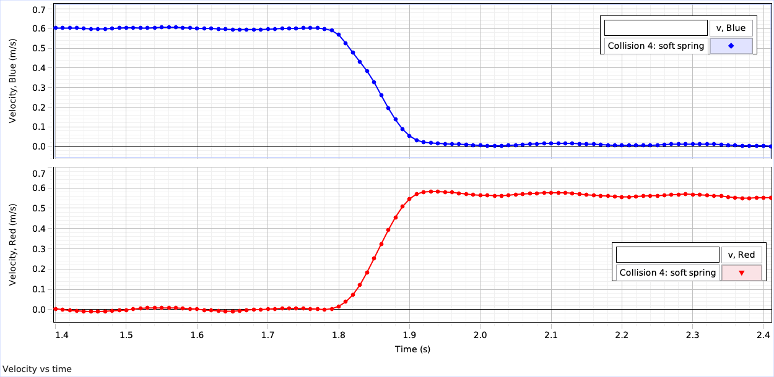
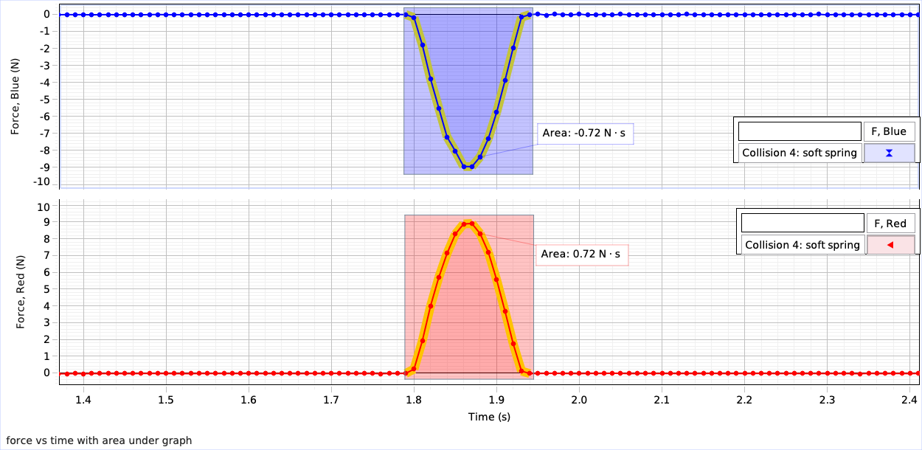

Collision 5: A blue cart is launched with initial speed 0.35 m/s toward a stationary red cart with the same mass. A soft spring is attached to the front of the stationary cart and both carts have sensors that record the force by the spring during the collision, as shown in the image below.
1.25 kg
1.25 kg
force sensors
v_{i, blue} = 0.35 m/s
v_{i, red} = 0 m/s
The experimental setup is as follows:
Initial speed of blue cart: 0.35 m/s Mass of blue cart: 1.25 kg
Initial speed of red cart: 0 m/s Mass of red cart: 1.25 kg
Attached to force sensor: soft spring

Below are velocity and force graphs for both carts during this collision.

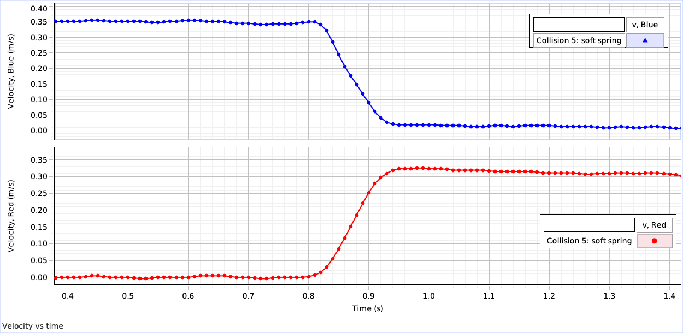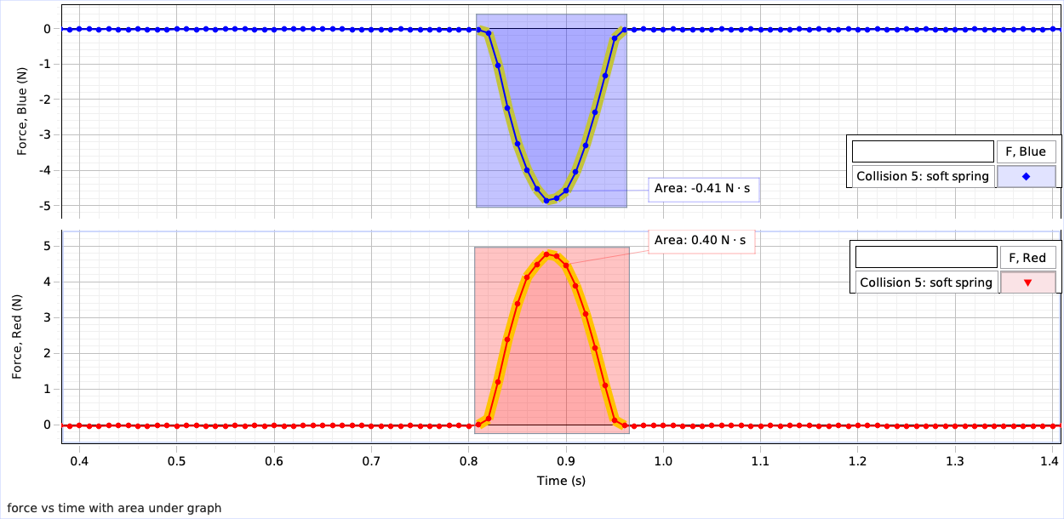
Collision 6: A blue cart is launched with initial speed 0.4 m/s toward a red cart with the same mass that moves in the opposite direction. A soft spring is attached to the front of the stationary cart and both carts have sensors that record the force by the spring during the collision, as shown in the image below.
1.25 kg
1.25 kg
force sensors
v_{i, blue} = 0.40 m/s
v_{i, red} = -0.40 m/s
The experimental setup is as follows:
Initial speed of blue cart: 0.4 m/s Mass of blue cart: 1.25 kg
Initial speed of red cart: -0.4 m/s Mass of red cart: 1.25 kg
Attached to force sensor: soft spring

Below are velocity and force graphs for both carts during this collision.
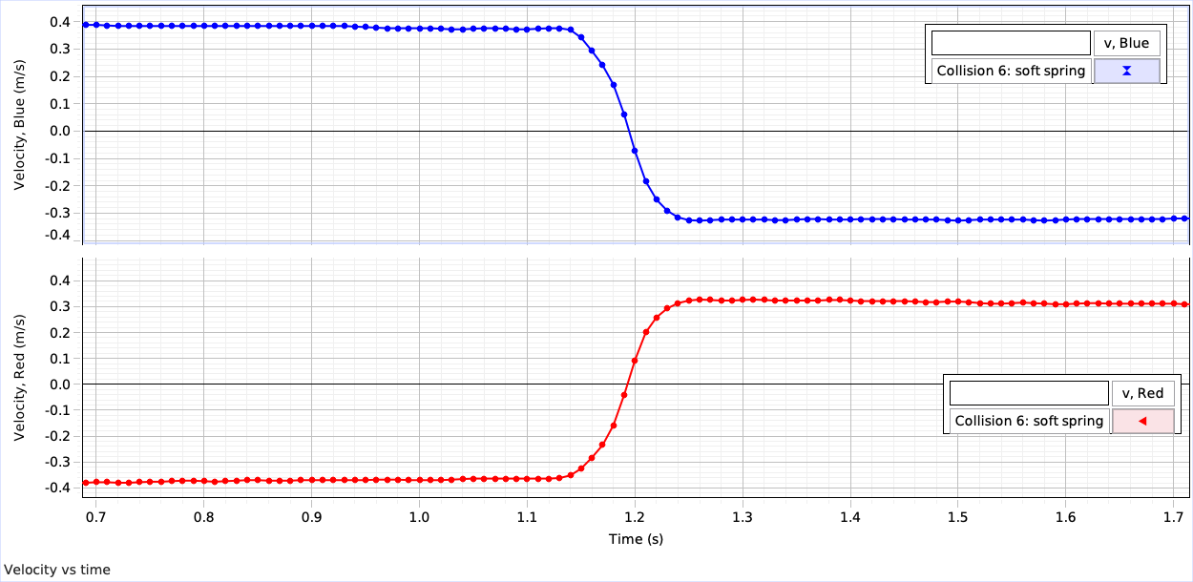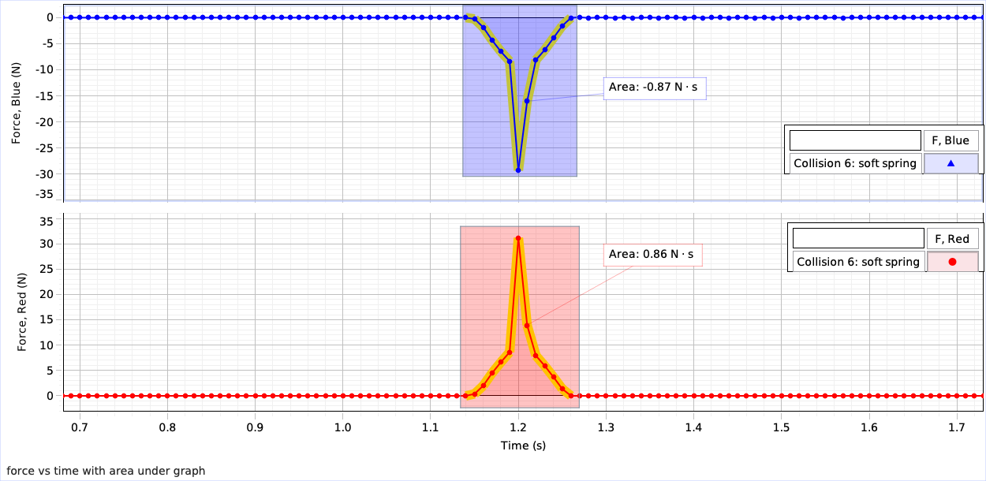
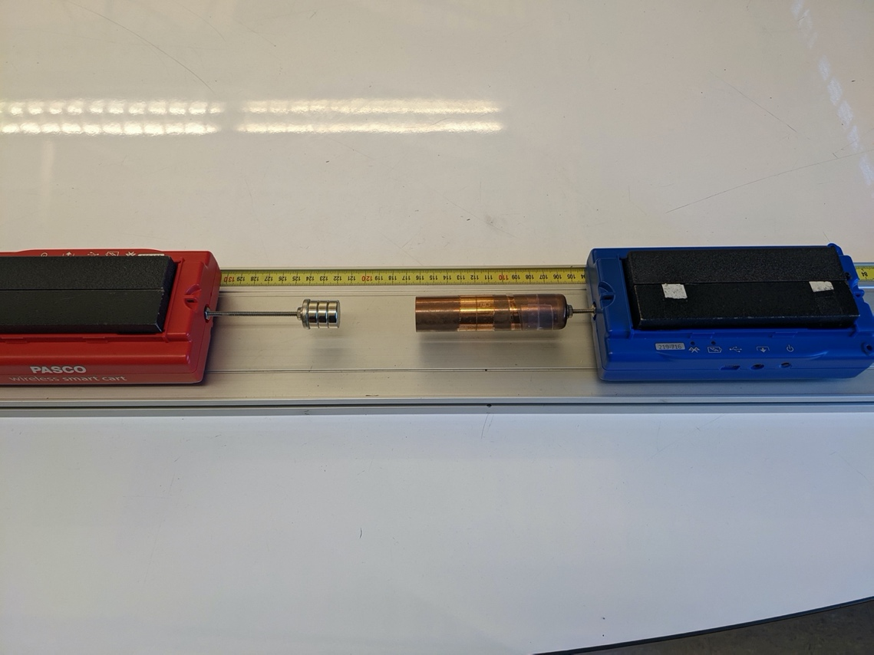
Collision 7: A blue cart is launched with initial speed 0.55 m/s toward a stationary red cart with the same mass. A stack of magnets is attached to the stationary cart and a copper tube is attached to the moving cart, as shown in the image below.
The experimental setup is as follows:
Initial speed of blue cart: 0.55 m/s Mass of blue cart: 1.25 kg
Initial speed of red cart: 0 m/s Mass of red cart: 1.25 kg
Attached to force sensor: magnets & copper tube

Below are velocity and force graphs for both carts during this collision.
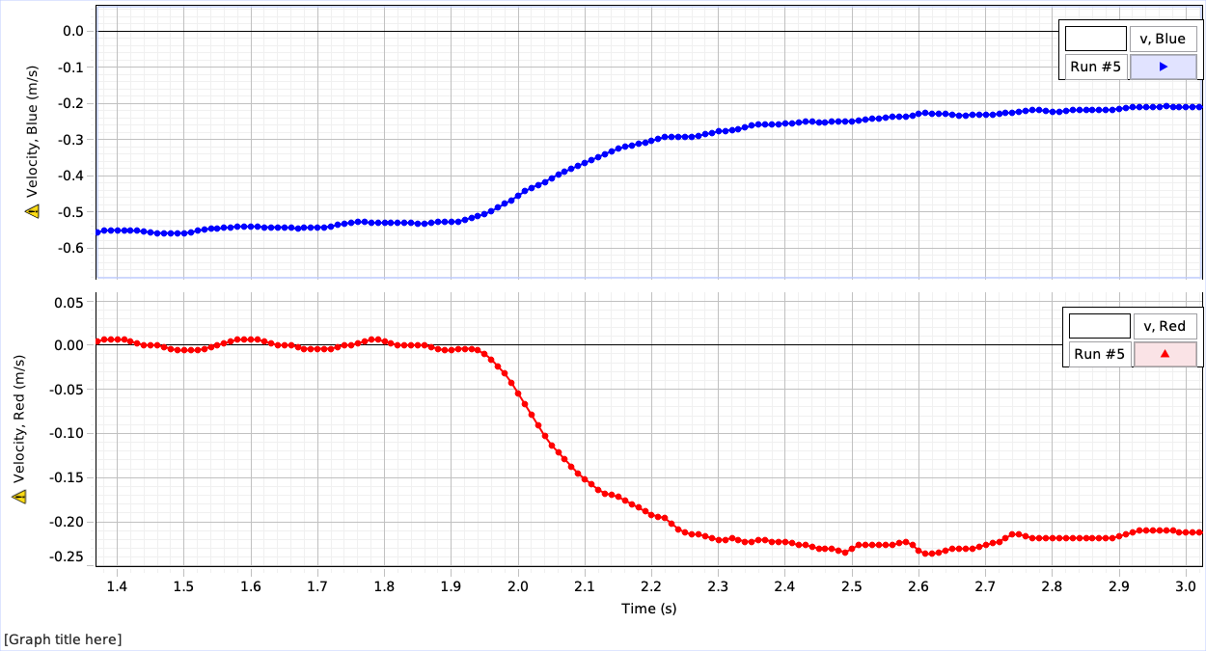
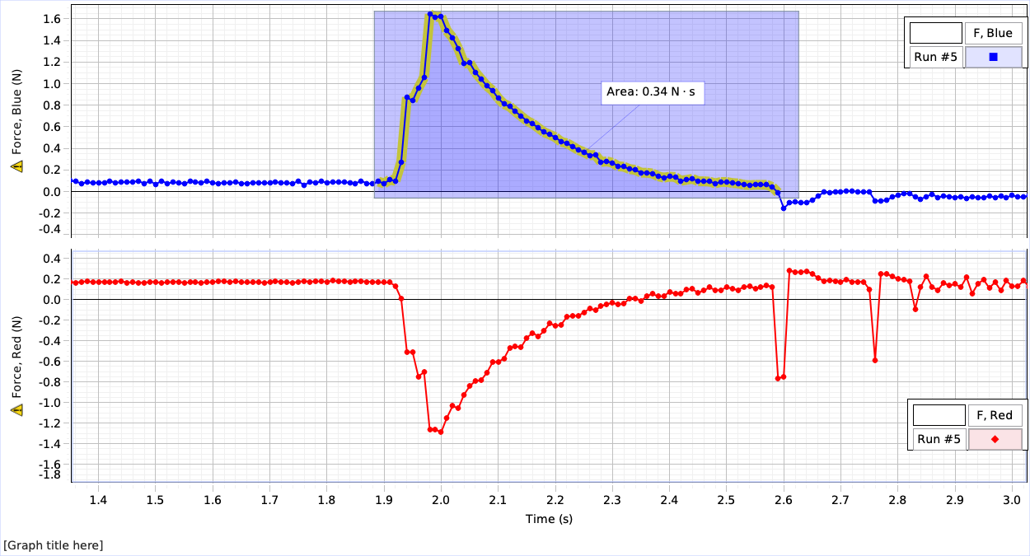
Collision 8: A blue cart is launched with initial speed 1.33 m/s toward a stationary red cart with greater mass. A soft spring is attached to the stationary cart, as shown in the image below.
0.25 kg
2.25 kg
force sensors
v_{i, blue} = 1.33 m/s
v_{i, red} = 0 m/s
The experimental setup is as follows:
Initial speed of blue cart: 1.33 m/s Mass of blue cart: 0.25 kg
Initial speed of red cart: 0 m/s Mass of red cart: 2.25 kg
Attached to force sensor: soft spring

Below are velocity and force graphs for both carts during this collision.
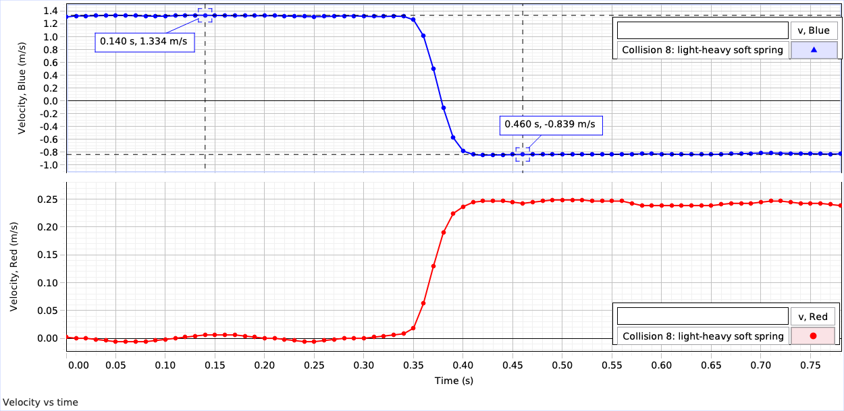
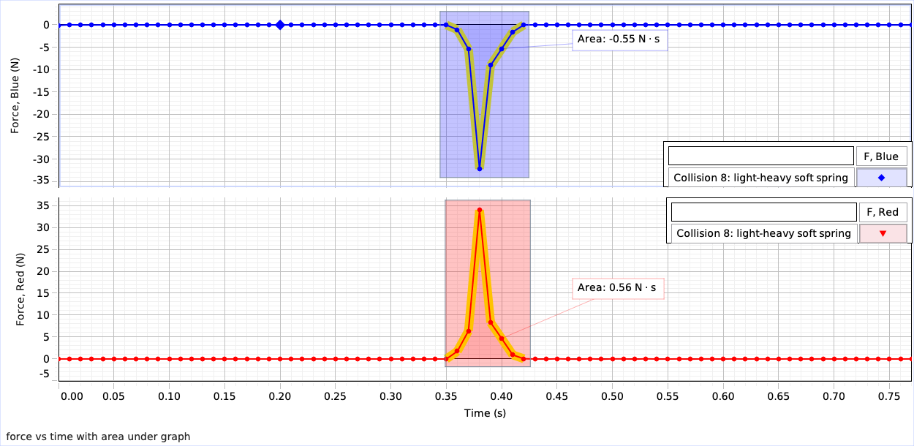

Collision 9: A blue cart is launched with initial speed 1.33 m/s toward a stationary red cart with greater mass. A stiff spring is attached to the stationary cart, as shown in the image below.
0.25 kg
2.25 kg
force sensors
v_{i, blue} = 1.33 m/s
v_{i, red} = 0 m/s

The experimental setup is as follows:
Initial speed of blue cart: 1.33 m/s Mass of blue cart: 0.25 kg
Initial speed of red cart: 0 m/s Mass of red cart: 2.25 kg
Attached to force sensor: stiff spring

Below are velocity and force graphs for both carts during this collision.

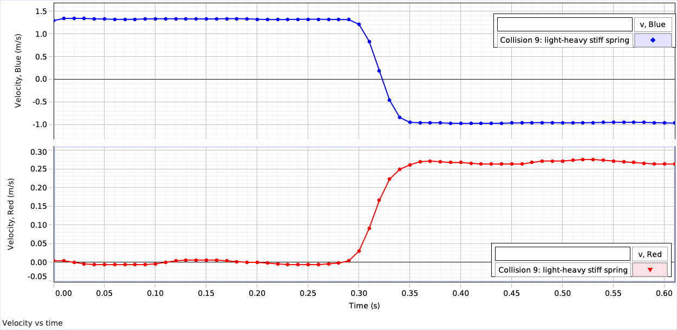
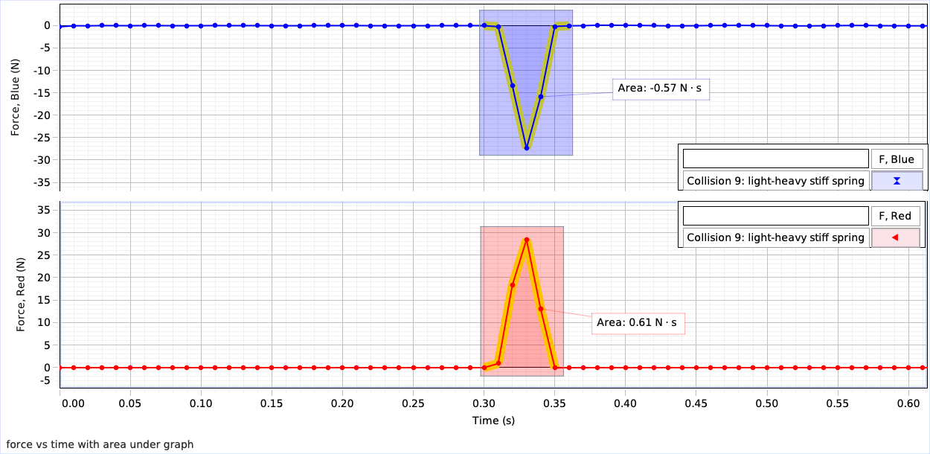
Collision 10: A blue cart is launched with initial speed 1.27 m/s toward a red cart moving the opposite direction with greater mass. A stiff spring is attached to the stationary cart, as shown in the image below.
0.25 kg
2.25 kg
force sensors
v_{i, blue} = 1.27 m/s
v_{i, red} = -0.43 m/s

The experimental setup is as follows:
Initial speed of blue cart: 1.27 m/s Mass of blue cart: 0.25 kg
Initial speed of red cart: -0.43 m/s Mass of red cart: 2.25 kg
Attached to force sensor: stiff spring

Below are velocity and force graphs for both carts during this collision.
