The goal of this worksheet is for you and your partners to identify a set of “rules” that you can use to explain and predict the behavior of electric circuits with several batteries and light bulbs. You already have many useful ideas about circuits, and the goal of this worksheet is to have you write those good ideas down, plus continue to refine and develop them as you answer a series of questions.

Use the model-building box below to record your ideas, observations, and questions about electric circuits as you work through this worksheet. You’ll return to this box regularly to connect and refine these ideas into a set of rules about how electric circuits work.
Model-Building Box: Circuits

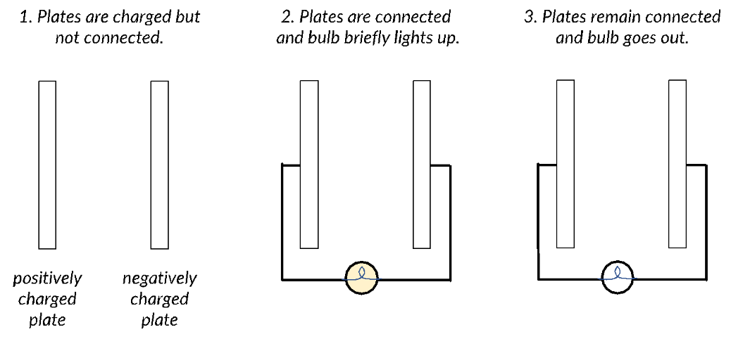
In what follows, assume that the brightness of a lightbulb is an indicator of the current that flows through it. Also assume that all light bulbs and batteries are identical, and wires are ideal.

Current model

The figure at right shows two capacitor plates, one with a positive net charge and one with a negative net charge. When a light bulb is connected to the capacitor plates as shown, the bulb lights up momentarily and then dims and goes out.

Describe what is happening to the charges in this scenario that makes the bulb briefly light up and then go out.

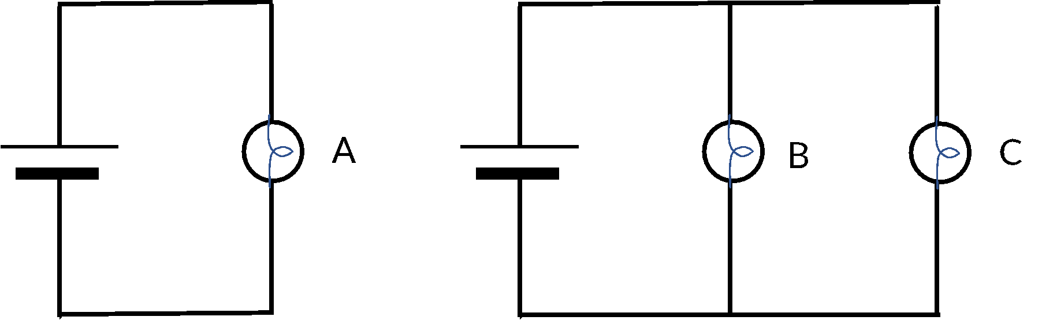

When a single bulb is connected to a battery as shown in the figure at right, why does it light and remain bright? Answer in terms of how charges move in the circuit.

In a circuit with a battery and light bulbs, the battery acts as a source of charge like the capacitor in the question above. There is a flow of charge from one side of the battery, through the circuit elements, and back to the other side of the battery. This flow of charge is called electric current.

In the circuits at right, all three bulbs are observed to be equally bright (A = B = C).

How does the current through bulbs A, B, and C compare? Explain why you think this is the case.

      - On the figures above, trace the flow of current from one side of the battery, through the circuit elements, and back to the other side of the battery. If the current splits and rejoins along the circuit path, represent this in your diagram.

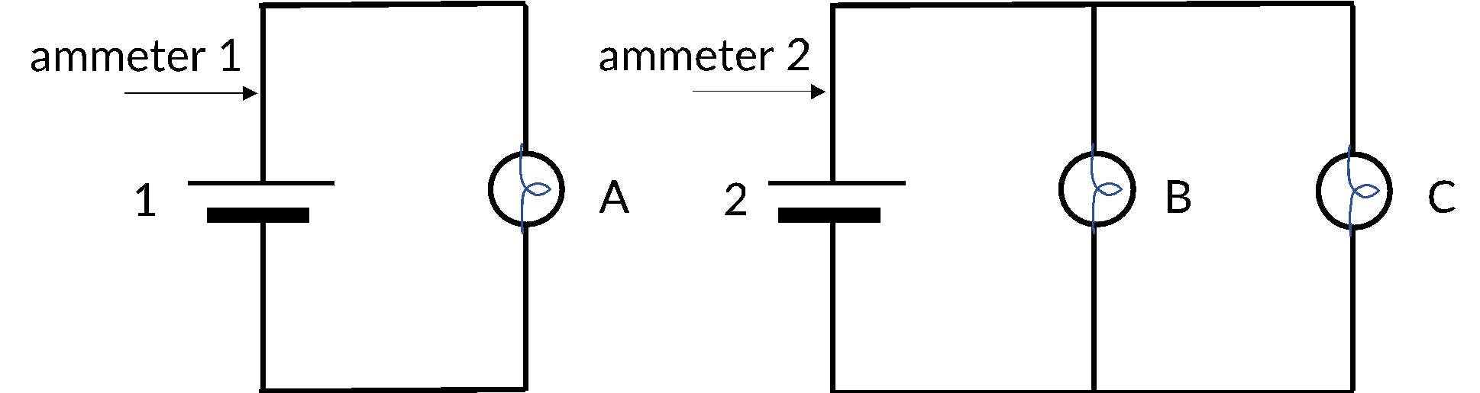
      - An ammeter (a device that measures the current at a specific location in the circuit) is placed in the circuits at the location shown. Is the reading of ammeter 1 greater than, less than,
or equal to the reading of ammeter 2?

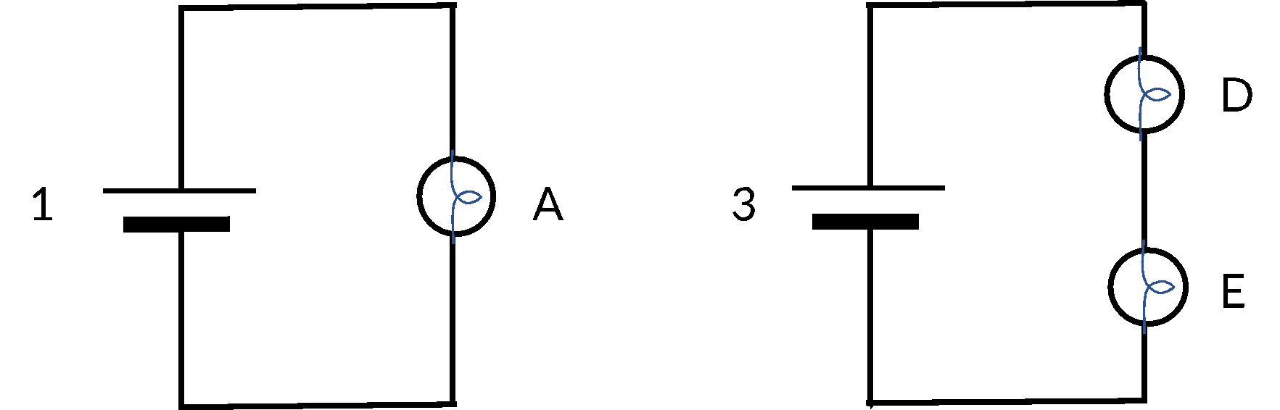
In the circuits at right, the brightness of the bulbs is observed to compare as follows: A is the brightest, and D and E are equally bright and dimmer than A (A > D = E).

Why is bulb A brighter than bulb D or E?

Revisit the model-building box on page 1 of this worksheet. Can you use only the ideas that you’ve written in the box to explain why bulb A is brighter than bulb D or E? If not, either modify or add to the ideas there so that the box represents the ideas you are using to explain this observation.

Why are bulbs D and E equally bright? As with question 2, add to or revise the ideas in the model-building box to account for this observation.

Trace the current flow for each circuit. Choose a variety of different locations for ammeters and say how their readings would compare to each other.

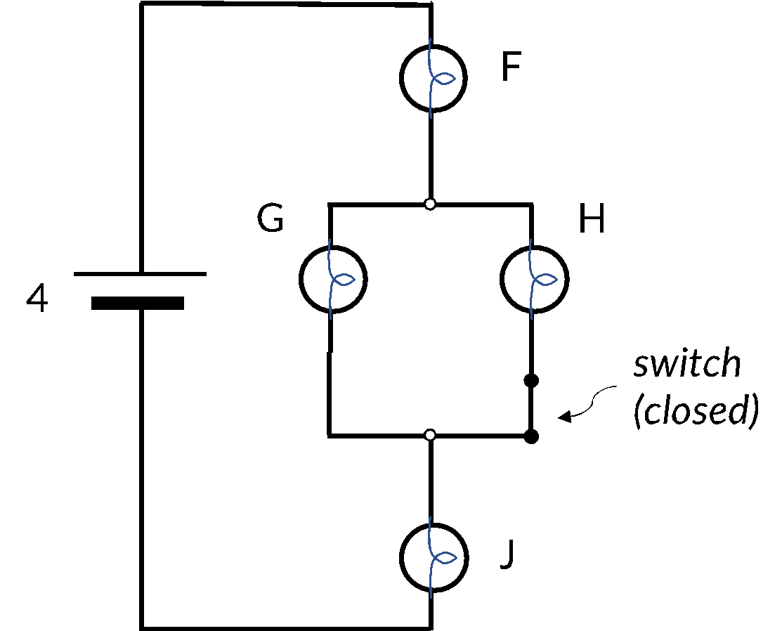
In the circuit at right, the switch is initially closed.

When the switch is closed, the ranking of the brightness of the bulbs is F = J > G = H. Explain this observation in terms of current and show your reasoning in a diagram.

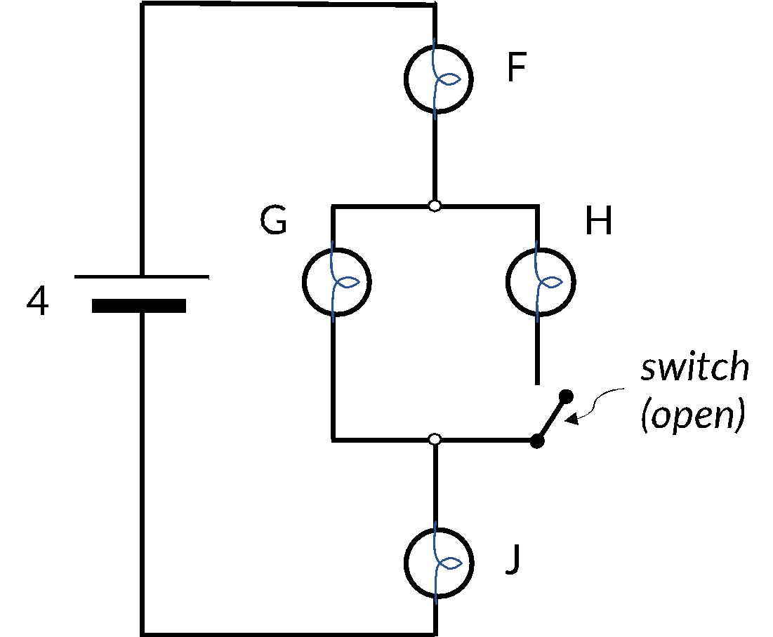
When the switch is opened, several changes are observed. For each observation below, explain in terms of current and show your reasoning in a diagram.

Bulb H goes out (does not light).

Bulbs F, G, and J are equally bright.

Bulbs F and J are dimmer when the switch is open.

Bulb G is brighter when the switch is open.

🡪 If you have not done so already, make sure to write down your ideas about the behavior of these circuits in the box on the first page. Are any of these ideas applicable to many or all of the scenarios you have considered up to this point in the worksheet? If so, make note of these in the Circuits Rules box.

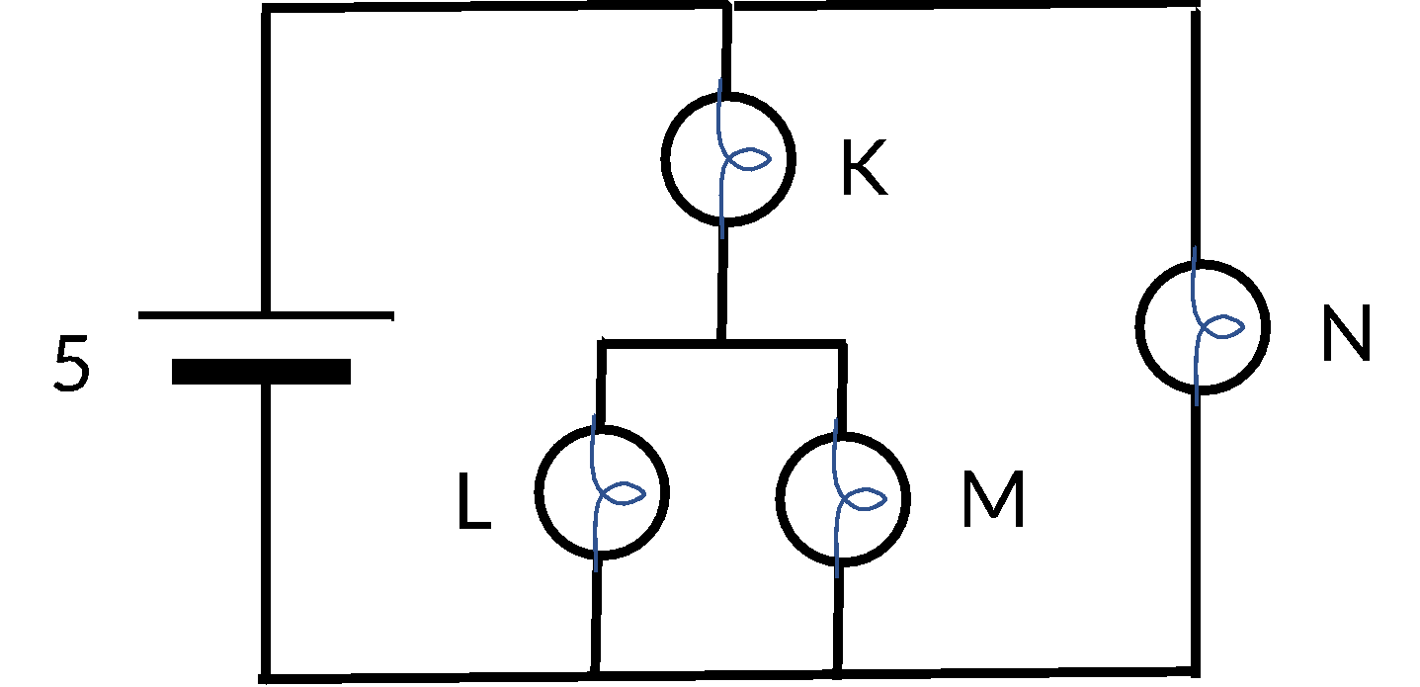
    - Use the ideas you developed in parts A-D to rank the brightness of the bulbs in the circuit at right.

🡪 Share your ideas with an instructor: how do the rules you’ve articulated apply to the circuit above?

Voltage model
- Let’s return to thinking about the bulb that connects the capacitor plates.
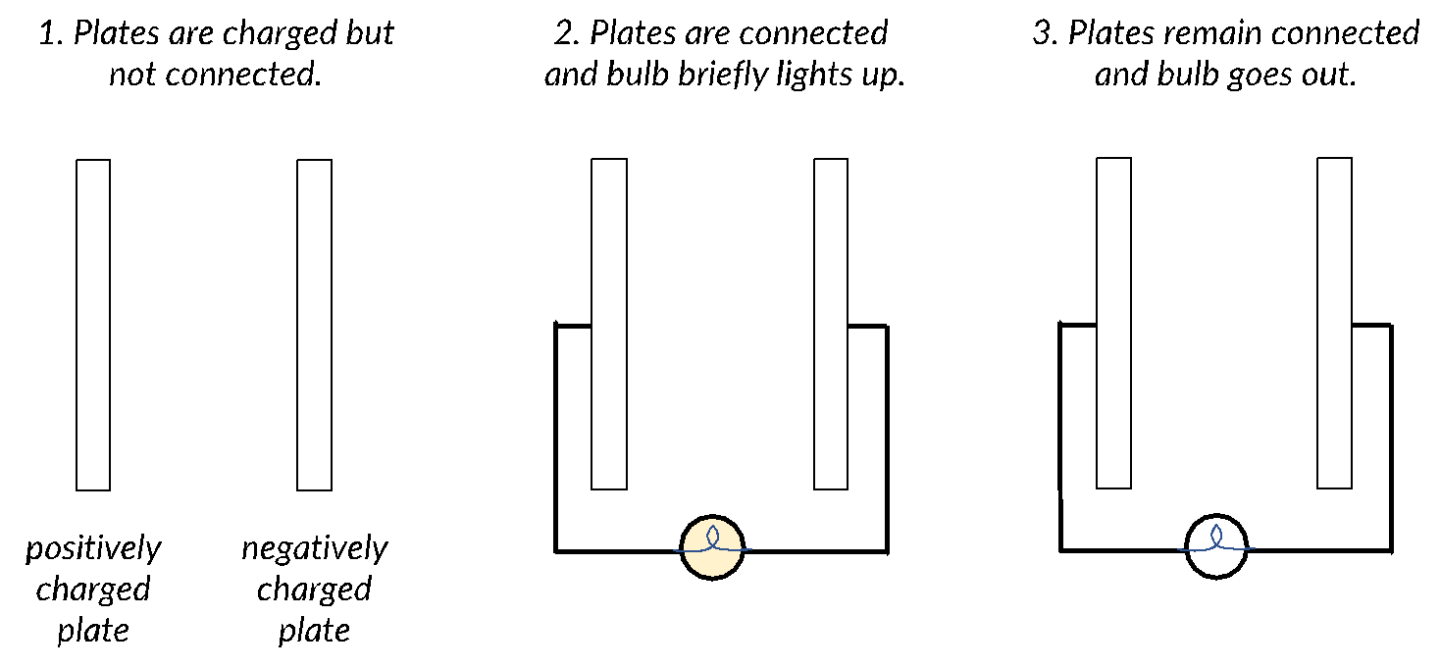

Describe what is happening to the potential difference across the plates in this scenario that makes the bulb briefly light up and then go out.

In a circuit, there is a potential difference (voltage) between the two sides of the battery, and therefore also across the circuit elements.

A voltmeter is used to measure the potential difference across bulbs A, B, and C, and it measures the same value for each. Explain why you think this is the case.

Assuming that the circuits above contain identical 9V batteries, map the voltages at various locations in the two circuits. What locations have the same voltage? Make sure your diagram is consistent with your answer above.
    - In the circuits at right, the brightness of the bulbs compares as follows: A is the brightest, and D and E are equally bright and dimmer than A (A > D = E).

      - Why is bulb A brighter than bulb D or E? Use your ideas about potential difference to explain this observation.

      - Why are bulbs D and E equally bright? Use your ideas about potential difference to explain this observation.

Assuming that batteries 1 and 3 in the circuits above are identical 9V batteries, map the voltages at various locations in the two circuits. What locations have the same voltage? Make sure your diagram is consistent with your answers to 1 and 2 above.

In the circuit at right, the switch is initially closed.

When the switch is closed, the ranking of the brightness of the bulbs is F = J > G = H. Explain this observation in terms of potential difference.

When the switch is opened, several changes are observed. For each observation below, explain in terms of potential difference.

Bulb H goes out (does not light).

Bulbs F, G, and J are equally bright.

Bulbs F and J are dimmer when the switch is open.

Bulb G is brighter when the switch is open.

III. A conceptual model for circuits
Now that you’ve made some observations about how circuits behave, your task is to write down a rule or set of rules for how current flows in a circuit. Your final set of rules should not only explain the observations you have already made, but also make predictions about how new circuits will behave.

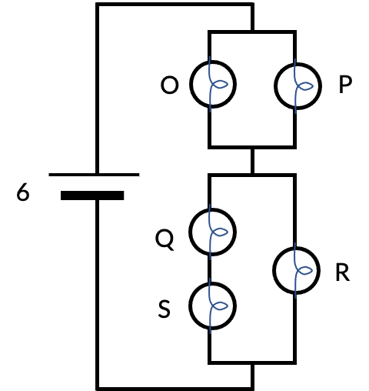
Reflect on your responses so far: What rule or set of rules explains why bulbs light up and how bright different light bulbs in a circuit are relative to each other? Your rule or rules should:
- say how current splits at a junction
- say how much current flows out of and into a battery
- include other relevant electricity and magnetism ideas such as charge and potential difference
- account for your observations in the previous questions
- make predictions about the brightness of bulbs/the flow of current in more complex circuits (for example, the one at right)

- Write down your rules in the model-building box on the first page, and share your model with an instructor.

