The goal of this worksheet is for you and your partners to identify a set of “rules” that you can use to explain and predict the behavior of a pulse on a string or spring. You already have many useful ideas about wave mechanics, and the goal of this worksheet is to have you write those good ideas down, plus continue to refine and develop them as you answer a series of questions.

Use the model-building box below to record your ideas, observations, and questions about pulse propagation as you work through this worksheet. You’ll return to this box regularly to connect and refine these ideas into a set of rules that predict how, and explain why, changes to the spring or to the generation of the pulse will affect the pulse’s shape and/or speed.
Model-Building Box: Pulse Propagation

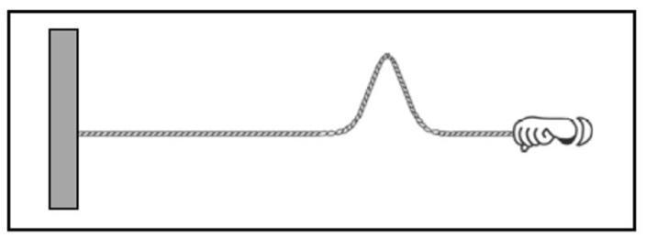
- Consider the following two experiments:

Experiment 1: Your instructor creates a pulse on a spring by flicking the end of the spring, as in the figure at right.

Experiment 2: Your instructor pulls the spring so that it is more taut than in scenario 1 (i.e., increases the tension in the spring) and then creates a pulse using the same hand motion as in scenario 1.

The pulse in experiment 2 travels down the spring faster (i.e., has a greater speed) than the pulse in experiment 1.

(Note that several springs are available in the classroom for you to use, if experimenting with them would help you to make sense of this phenomenon.)

  - Why does it make sense for a pulse to move faster on a higher-tension spring? Be as thorough as possible in your explanation. You may find it helpful to use pictures or diagrams to communicate your explanation.

  - There are a number of different well-justified explanations for why this happens. Find someone else whose explanation makes sense to you, but is different than yours, and summarize it here.

  - Each of these explanations implies (or overtly states) a mechanism for pulse propagation – i.e., how or why the pulse moves down the spring. For both of these explanations, write down what that mechanism is in the space below.

🡪 If you have not done so already, make sure to write down your ideas in the box on the first page. Are any of these ideas applicable to many or all of the scenarios you have considered up to this point in the worksheet? If so, make note of these in the Model Building Box.

- In Part I, you constructed an explanation for why a pulse propagates faster on a higher-tension spring, and you used your explanation to articulate a mechanism for pulse propagation. One goal of physics is to articulate mechanisms that can explain many different phenomena. The process for doing so is like what you will do in this worksheet: coming up with a mechanism in one experiment (Part I), and then applying and refining it in additional experiments. You’ll do that next.

In a new experiment (experiment 3), you will generate a pulse using the same hand motion as experiment 1 (i.e. same speed, height, and duration of motion) on a heavier spring with the same tension as experiment 1.

  - What does each mechanism you described in I.c tell you will happen to the speed and/or shape of the pulse in experiment 3, as compared to experiment 1? For each prediction, use the associated mechanism to explain why you think this will happen. Your answer should take the form of something like, “If I think of pulse propagation as _______, then increasing the mass of the spring will mean the pulse is ______ in experiment 3, because _______.”

Explain your prediction(s) to an instructor, who will help you set up experiment 3.
  - Now, conduct experiment 3. Record the details of what happens in this experiment below.

  - If the results of experiment 3 are not what you predicted in part a, how can you explain your observations? If warranted, revise your mechanism for pulse propagation so that it can account for the results of both experiments 2 and 3.

🡪 If you have not done so already, make sure to write down your ideas in the box on the first page. Are any of these ideas applicable to many or all of the scenarios you have considered up to this point in the worksheet? If so, make note of these in the Model Building Box.

- The goal of your next experiment is to help you improve, extend, or add detail to your mechanism for propagation.

One possibility for such an experiment would be to change something about the hand motion used to generate the pulse, keeping the tension and mass density of the spring the same as in experiment 1. (For example, what happens to the speed and shape of the pulse if the hand moves up and down twice as fast?)

Alternately, you could choose a new experiment that will help you answer a question about pulse propagation that has emerged in the course of your discussion of this worksheet.

    - With your partner or group, choose a new pulse propagation experiment to conduct.
      - Briefly explain why you chose this experiment.

      - What does the mechanism you described in parts I (c) and/or II (c) predict about what will happen in this experiment and why?

Explain your prediction(s) to an instructor, who will help you set up your experiment.

    - Test your prediction by conducting this experiment. Do the results of your experiment agree or disagree with your prediction? Explain.

    - If the results of experiment 3 are not what you predicted in part a, how can you explain your observations?

    - Based on the results of your experiment, find at least one way to modify or add specificity to your mechanism for pulse propagation from parts I and II.

