Complete the following questions and submit as this week’s homework assignment.
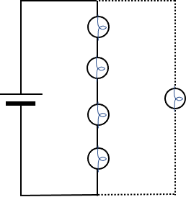
      - Consider four identical bulbs connected in series to an ideal battery. A fifth identical bulb is then connected in parallel with the first four, as shown in the figure at right.
        - When the fifth bulb is connected, will the brightness of the four bulbs increase, decrease, or remain the same? Explain your reasoning.

        - When the fifth bulb is connected, will the current out of the battery increase, decrease, or remain the same? Explain your reasoning.

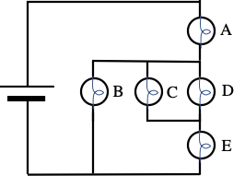
      - In the circuit at right, the bulbs are identical, and the battery is ideal. Rank the brightness of the bulbs in the circuit at right. Explain your reasoning for your ranking.

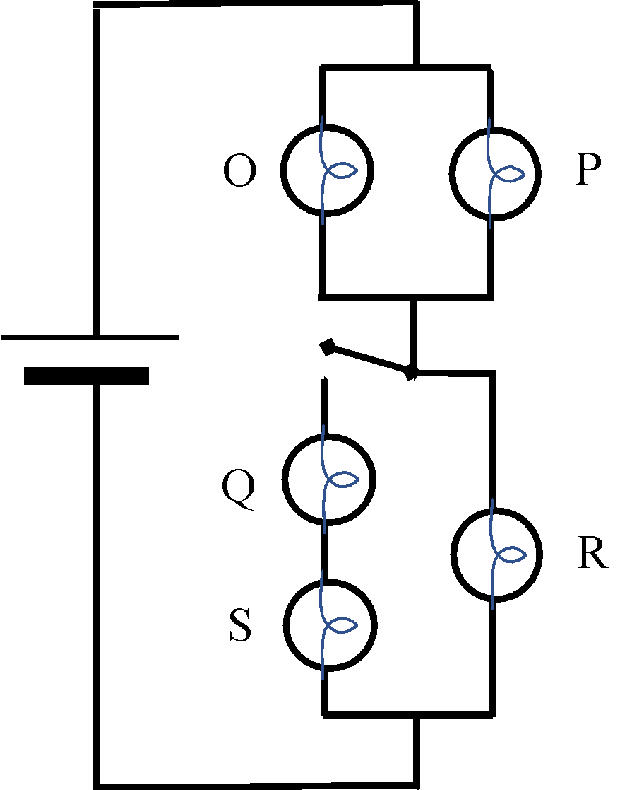
      - In the circuit at right, the switch is initially open, and the ranking of the brightness of the bulbs is: R > O = P. Bulbs Q and S do not light. When the switch is closed, several changes are observed. For each observation below, give an explanation.

        - Bulb R is dimmer than it was when the switch was open.

        - Bulbs Q and S light up and are equally bright.

        - Bulbs O and P are brighter than they were when the switch was open.

        - Bulbs O and P are brighter than Q and S.

