Mach-Zehnder Interferometer (MZI) with Single Photons: Tutorial

Acknowledgment: The simulation used in this tutorial was developed by Albert Huber (http://www.physik.uni-muenchen.de/didaktik/Computer/interfer/interfere.html)

The setup for the ideal Mach-Zehnder interferometer (MZI) shown below is as follows:
- All angles of incidence are 45° with respect to the normal to the surface.
- For simplicity, we will assume that a photon can only reflect from one of the two surfaces of the identical half-silvered mirrors (beam splitters) BS1 and BS2 because of an anti-reflection coating on one of the surfaces.
- The photo-detectors D1 and D2 are point detectors located symmetrically with respect to the other components of the MZI as shown.
- The photons originate from a monochromatic coherent point source. (Note: Experimentally, a source can only emit nearly monochromatic photons such that there is a very small range of wavelengths coming from the source. Here, we assume that the photons have negligible “spread” in energy.)
- Assume that the photons propagating through both the U and L paths travel the same distance in vacuum to reach each detector.
- All photo-detectors are ideal.
- Polarizers do not introduce phase shifts.
- All measurements are ideal projective measurements.

- In the classical usage of the Mach-Zehnder Interferometer, a “beam” of light is sent which gets separated spatially after passing through BS1. Now, we will send one photon at a time through the MZI.
- In all of the discussions below, ignore the effect of polarization of the photons due to reflection by the beam splitters or mirrors.
- Assume that beam splitters BS1 and BS2 are infinitesimally thin so that there is no phase shift when a photon propagates through them.
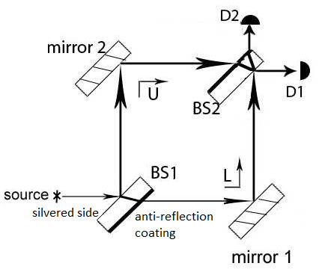
- For the entire tutorial, assume that a large number of photons ($N$) are sent one at a time.

The goals of this tutorial are to use MZI with single photons (photons sent one at a time) to understand:
- Interference of a photon with itself due to the two possible paths
- A photon has a nonzero probability of being found in two (or more) locations simultaneously (e.g., U and L paths of MZI).
- Detectors D1 and D2 are complementary: a single photon will make only one detector click, not both at the same time because measurement will collapse the state of the photon.

- How removing or adding optical elements (beam splitter 2, detectors, polarizers) can:
- Cause the photon to exhibit properties of either a wave or a particle.
- Give “which path” information about the photon arriving at the detectors, destroying the interference pattern at the detectors.
- Case 1: Effect of adding or removing beam splitter 2
  - Removing beam-splitter 2: gives “which-path” information for photons arriving at the detectors and destroys the interference pattern
  - Delayed choice experiment: interference pattern is observed at the detectors even if beam-splitter 2 is added after the photon is already in the U and L paths of the MZI
- Case 2: Effect of adding additional photo-detectors in either the U or L path of the MZI
  - Measurement of the photon’s position via the detector in either the U or L path collapses the state of the photon, giving “which-path” information about the photon arriving at the detector and destroying the interference pattern
  - Presence of a photo-detecting bomb can be detected without light ever reaching it (Interaction free measurement)
- Case 3: Effect of adding polarizers in the U or L path of a single photon:
  - A polarizer in one of the two paths (U or L) of MZI can give “which-path” information about some of the photons arriving at the detector with polarization perpendicular to the polarization axis of the polarizer placed in either the U or L path.
  - Polarizers with orthogonal polarization placed in both the U and L paths provide “which-path” information about all of the photons arriving at the detector, destroying the interference pattern.
- Case 4: “Quantum eraser”: first obtaining “which-path” information then destroying the “which-path” information and recovering the interference pattern observed at the detectors (or screen) placed after beam splitter
Note: A single photon can be thought of, e.g., as having a transverse Gaussian profile or can be represented by a “many ray” model, as opposed to being a localized particle represented as a delta function in position.

Summary of the phase shifts in the MZI warm-up
 | Initially in medium with lower n | Initially in medium with higher n
Reflection at interface | Phase shift of π | No phase shift
Transmission at interface | No phase shift | No phase shift
Propagation through a medium | Phase shift depending on thickness and refractive index n
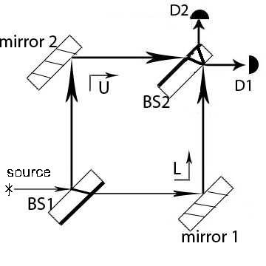
In questions 1-14, assume that the source emits a highly collimated beam of photons (photons emitted as a single ray having an infinitesimally small width).

Goal 1: Interference of a photon with itself due to the two possible paths

- A) If we send a single photon from the source (instead of a beam of photons), is it possible that one photon can go through both the U and L paths simultaneously after passing through the first beam-splitter BS1?
  - No. When a single photon is sent, it can only take one of the paths U or L with equal probability.
  - No. When a single photon is sent, it will take path U if it is unpolarized. It will take path L if it is polarized.
  - Yes. A single photon can take both paths of the MZI simultaneously.
  - None of the above.
1. B) Discuss your preceding answer with a partner and explain your reasoning.

- A) Consider the following conversation between Student A and Student B:
- Student A: If we send one photon at a time, there is no way to observe interference at detectors D1 and D2. Interference is due to the superposition of waves from the U and L paths. A single photon must choose either the U or the L path.
- Student B: I disagree. We should observe interference because a single photon can go through both the U and L paths simultaneously and can interfere with itself. We can observe constructive, destructive or intermediate interference at the detectors depending on the phase difference between the U and L paths of the photon state arriving at a detector from the U and L paths. Only one of the detectors will click for each photon. Clicking of a detector means that the photon was registered there and the photon state collapsed.

With whom do you agree?

  - Student A
  - Student B
  - Neither
2. B) Discuss your preceding answer with a partner and explain your reasoning.

- A) Consider the following conversation between three students:
- Student A: After the photon exits beam-splitter 1 (BS1), BS1 divides the photon state into two halves. That means that a photon has been divided into two photons with the energy of each photon in the two paths being half of the energy of the photon that entered BS1. If the path difference in the U and L paths of the MZI were set up such that there was an intermediate interference at each detector D1 and D2 (neither fully constructive nor fully destructive), there would be a possibility of both detectors registering a photon at the same time with half the energy of the incoming photon.
- Student B: I disagree. Beam-splitter 1 causes the incoming photon state to become a superposition of the two path states U and L, but neither the photon nor its energy is split in half. If the energy was split in half, this would mean that the wavelength of the photon was doubled, which is not the case. Beam-splitter 1 simply makes the single photon state delocalized.
- Student C: I agree with Student B’s statement. For a single photon, if the MZI was set up such that there was intermediate interference at detectors D1 and D2, only one detector will register a photon, not both. The registering of a photon in a detector collapses the state of the photon and localizes it. We observe interference at the detectors because a single photon interferes with itself.
With whom do you agree? You can agree with more than one student.
- Student A
- Student B
- Student C
3. B) Discuss your preceding answer with a partner and explain your reasoning.
- Checkpoint
  - A single photon can be delocalized and can be in both the upper and lower paths of the MZI simultaneously. The photon is in a superposition of the U and L path states.
  - A single photon can interfere with itself to produce interference at the detectors.

- A) Consider the following conversation between three students:
- Student A: How can a single photon be in both the U and L paths of the MZI simultaneously if only one detector D1 or D2 clicks and registers a photon? It must go through only one path if only one detector clicks.
- Student B: The registering of a photon at the detector corresponds to a measurement of the photon’s position via its interaction with the atoms in the detector. It collapses the state of the photon so that its position becomes sharply localized. The photon is absorbed by the detector during the detection process.
- Student C: I agree with Student B’s statement. A single photon can be delocalized or localized depending on the situation. For example, the single photon state is delocalized while going through the U and L paths but becomes localized when a detector clicks and a photon is registered there.
With whom do you agree? You may agree with more than one student.
- Student A
- Student B
- Student C
4. B) Discuss your preceding answer with a partner and explain your reasoning.

- A) Consider the following conversation between Student A and Student B about the MZI with point detectors as shown:
- Student A: I don’t understand. Since a single photon is delocalized and can be in both the upper and lower paths of the MZI simultaneously, there should be a finite probability that detectors D1 and D2 will both click at the same time and each would register the photon when a single photon is sent through the MZI.
- Student B: I disagree. For a given photon, only one of the detectors will click because there is only a single photon and the photon state becomes localized upon detection of the photon. The clicking event due to registering of a photon at the detectors is complementary (only one of them will click and detect a photon). Thus, it is not necessary to have both detectors D1 and D2 in the experiments we have discussed so far. A single detector can yield the same information. If the detectors are symmetrically situated as in the figure above, the interference observed at each detector will be correlated with the other. In our present case, in which D1 is set up to show completely constructive interference and will always register the photon, D2 will show completely destructive interference and will never register the photon.
With whom do you agree?
(a) Student A
(b) Student B
- Neither
5. B) Discuss your preceding answer with a partner and explain your reasoning.

- Checkpoint:
  - When a detector clicks, the detector registers a photon and localizes it.
  - For a given photon, only one of the detectors in the MZI will click or register a photon. The registering of a photon at the detectors is complementary (only one of them will click for a given photon) because the state of the photon becomes localized upon detection at a detector.

- Consider the following conversation between three students about a source which emits a large number of photons ($N$) one at a time for the given setup:
- Student 1: In the MZI setup shown above, $N/2$ photons will arrive at detector D1 and $N/2$ photons arrive at detector D2. We observe destructive interference at detector D2 because the photon state from the two paths is completely out of phase when a photon arrives there. Thus, the photon is “killed” at detector D2 upon arrival. We observe constructive interference at detector D1 because the photon state from the U and L paths arrives in phase there. Since $N/2$ photons arrive at detector D1 in phase (the other half are killed at detector D2), D1 will register a photon with 50% probability.
- Student 2: Yes, and each photon has a 50% probability of arriving at detector D2 and getting “killed” there. Thus, detector D2 will click and register a “dead” photon half of the time and detector D1 will register a photon the other half of the time.
- Student 3: I disagree with both of you. Think of just one photon propagating through the MZI setup given. That single photon will always arrive at detector D1 in the given setup because the phase difference is such that there is constructive interference at D1. The photon will never arrive at detector D2 because the phase differences from the two paths are such that there is destructive interference at D2. The detector D2 never clicks in the given case (never registers a photon) because the photon never arrives there. If $N$ photons are emitted from the source, all $N$ photons arrive at D1. Thus, D1 registers a photon 100% of the time, and D2 registers a photon 0% of the time in the given setup.
With whom do you agree? Explain your reasoning.
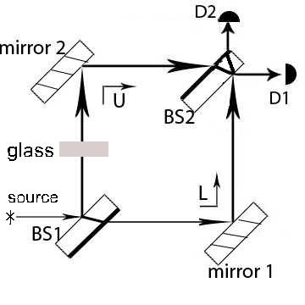

7. A) Consider the following conversation between Student C and Student D:
- Student C: For the setup provided, we have completely constructive interference at detector D1 and completely destructive interference at detector D2. But if we insert a phase shifter, e.g., a glass piece of a certain thickness, in one of the paths (as shown above), we can create a situation with intermediate interference at each detector such that the interference at each detector is neither completely constructive nor completely destructive.
- Student D: What would be the effect of gradually changing the thickness of the phase shifter placed in one of the paths, e.g., the U path?
- Student C: As you change the thickness of the glass, you will see the probability of each detector clicking change due to intermediate interference at both detectors. For example, for some thickness of glass, D1 may have 70% probability of clicking (and registering a photon) and D2 may have 30% probability of clicking (and registering a photon). However, you will not know ahead of time which detector will click.
- Student D: But even for an intermediate interference case when there is a finite probability for each detector registering a photon, both detectors will NEVER click simultaneously when a single photon is sent since the interaction of a photon with the detector is a measurement of the photon’s position. It collapses the state of the single photon and localized it.
Do you agree with the students?
7. B) Explain your reasoning.

Summary: Goal 1-Interference of a single photon with itself due to the two possible paths
  - A single photon can be delocalized and can be in both the upper and lower paths of the MZI simultaneously (i.e., the photon can be in a superposition of the U and L path states).
  - A single photon can interfere with itself to produce interference effects at the detectors.
- Depending on the phase difference of the photon state arriving at a detector from the U and L paths, there can be constructive, destructive, or intermediate (neither completely constructive nor destructive) interference at each detector due to a single photon interfering with itself. (see MZI warm-up questions 13-18)
- When a detector registers a photon, the detector will “click.”
  - When a single photon arrives at a detector such that the U and L path contributions are in phase, it corresponds to constructive interference and the detector will register the photon. When the phase differences are such that there is destructive interference at a detector, the photon never arrives there and that detector never clicks or registers a photon.
- When a single photon is sent through the MZI, only one detector will click, not both at the same time.
- The interaction of a photon with the detector can be thought of as a measurement of the photon’s position which collapses and localizes the delocalized state of the photon. The photon is absorbed by the detector during the detection process.

Goal 2: How adding or removing optical elements can yield “which-path” information about the photon arriving at the detector and destroy interference at detectors D1 and D2

Case 1: Adding or removing beam-splitter 2 (BS2)

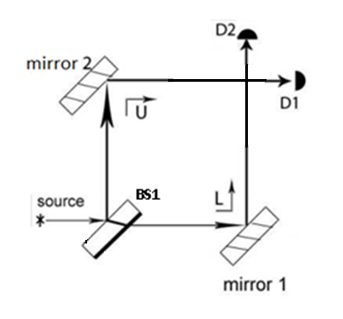
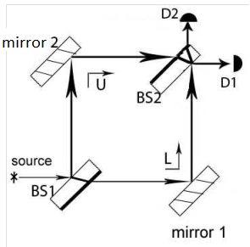
Consider the single photon experiment with the MZI setup, but with a removable second beam splitter (BS2).

MZI with BS2 MZI without BS2

- If the second beam splitter BS2 is removed (see the figure to the right above), which one of the following is true about a single photon propagating through the MZI (after BS1) before it reaches detector D1 or D2?
- It is delocalized, which means it is in a superposition state of the U and L path states.
- It will either propagate along the U path or along the L path, not along both paths at the same time.
- It must take the U path because the state of the photon has collapsed to the upper path state before the photon reaches the detector.
- It must take either the U or L path, but the probability is higher for it to take the U path.

- If the second beam-splitter BS2 is removed (see the figure to the right above), which one of the following is true about the single photon if detector D1 registers a photon?
- The state of the photon has collapsed to the U path state.
- Without BS2, detector D1 projects the component of the photon state along the U path, but before the registering of the photon in detector D1 the state was a superposition of the U and L path states.
- If BS2 is removed, the photon is never in a superposition of the U and L path states after BS1 and it must definitely be in the U path in order to reach D1.
- (I) only
- (III) only
- (I) and (II) only
- None of the above.

- Consider the following conversation between three students:
- Student A: I think the answer to the preceding question is that the single photon was never in a superposition state of the U and L paths after BS1 if BS2 is not present. If BS2 is removed, then the photon after BS1 either travels along the U path or L path, not both. If D1 registers a photon, the photon must have propagated only along the U path after BS1. If D2 registers a photon, the photon must have propagated only along the L path after BS1.
- Student B: I disagree. Before the photon reaches the detectors D1 or D2, it was in a superposition of the U and L path states even when BS2 is not present. If detector D1 registers a photon, it corresponds to a measurement of photon position and the state of the photon collapses to the U path state.
- Student C: I agree with Student B’s statement. Detector D1 can only project the component of the photon state along the U path if BS2 is not present, but before the registering of the photon at detector D1, the state was a superposition of the U and L path states. Thus, after detector D1 clicks we have “which-path” information in that only the component along the U path can be projected in detector D1. If detector D2 registers a photon, the state of the photon collapses to the L path state because detector D2 can only project the component of the photon state along the L path if BS2 is not present. Thus, after detector D2 clicks we have “which-path” information in that only the component along the L path can be projected in detector D2.
With whom do you agree? Explain.

- Checkpoint:
- When BS2 is removed:
  - There is no interference at the detectors D1 and D2.
- The photon state is still in a superposition of the U and L paths after BS1 until the detection of the photon at a detector.
- Detector D1 can only project the component of the photon state along the U path and detector D2 can only project the component of the photon state along the L path.
- We have “which-path” information about the single photon when the photon arrives at a detector D1 or D2 (in that detector D1 can only project the component along the U path and detector D2 can only project the component along the L path).

MZI with BS2 MZI without BS2

- A) If the second beam-splitter BS2 is removed, choose all of the following statements that are true:
- We have “which-path” information about the photon when a detector D1 or D2 registers a photon.
- Placing the detector D1 anywhere in the U path is equivalent to placing it at the end of the path (as in the figure above).
- Placing the detector D2 anywhere in the L path is equivalent to placing it at the end of the path (as in the figure above).
- (I) and (II) only
- (I) and (III) only
- (II) and (III) only
- All of the above.

11. B) Consider the following conversation between two students:
- Student A: I don’t understand the role of beam-splitter 2 (BS2) then. Will we observe interference at detectors D1 and D2 without BS2 if a photon is in a superposition of the U and L path states right after BS1?
- Student B: No. There is no interference observed at the detectors without BS2 because detector D1 can only project the component of the superposition state along the U path and detector D2 can only project the component of the superposition state along the L path when BS2 is not present. Thus, we know the photon state when a particular detector clicks and there is no interference due to the photon state from the U and L paths.
- Student A: What changes when BS2 is inserted?
- Student B: There will be interference at each detector because BS2 evolves the superposition state of the photon in such a way that the photon state from both U and L paths can be projected by each detector. Thus, when a photon arrives at a detector when BS2 is present, then the phase difference between the U and L paths in the superposition state at a detector will lead to interference of the photon with itself.
Do you agree with Student B’s reasoning? Explain.

- Choose all of the following statements that are true about the case when the second beam splitter BS2 is removed:

- The point detectors D1 and D2 can only project the superposition state of the photon only along the U path state or L path state, respectively.
- No interference is observed at either detector and each detector has a 50% probability of registering a photon, regardless of the phase difference between the U and L paths.
- It is useless to calculate the phase difference between the photon state due to the U and L paths for information about interference because we have “which-path” information about each photon that arrives at detectors D1 or D2.

- (I) and (II) only
- (I) and (III) only
- (II) and (III) only
- All of the above.

- Consider the following conversation between two students:
- Student 1: If beam-splitter 2 is removed, detectors D1 and D2 each will register a photon 50% of the time since we have “which-path” information when a detector registers a photon. There will not be any constructive or destructive interference at the detectors in this case. But when we insert beam-splitter 2, the detectors D1 and D2 will both register a photon 100% of the time when a photon is sent through the MZI.
- Student 2: I agree with your first statement but do not agree with the second statement. Even when we insert beam-splitter 2, we only have one detector clicking each time a photon is registered since the registering of a photon corresponds to a measurement of the photon’s position and localizes the photon. For the setup given at the beginning of this tutorial with BS2 present, we observe only constructive interference at detector D1 because the photon state from the two paths arrives in phase at D1. All of the photons originating from the source are registered at D1 when BS2 is present since there is completely constructive interference at D1, as in the given setup. We observe completely destructive interference at detector D2 because the phase difference from the two paths is π there (completely out of phase). So detector D2 never clicks and no photon is registered at detector D2.
With whom do you agree? Explain.

- Checkpoint:
- When BS2 is removed:
  - The single photon will no longer interfere with itself and no interference is observed at detectors D1 or D2.
  - Since there is no interference, the detectors D1 and D2 click with equal probability (each detector has an equal probability of registering a photon), independent of the phase difference between the U and L paths.

MZI with BS2 MZI without BS2
- A) Consider the following conversation between Student A and Student B:
- Student A: If we insert BS2 after a photon has already passed through the first beam splitter BS1 (and is in a superposition state of the U and L paths), we would observe completely constructive interference at D1 and completely destructive interference at D2.
- Student B: I disagree. After the photon propagates through beam splitter 1, it has chosen either the U or L path if BS2 is not there. If we insert BS2 after the photon propagates through BS1 but before the photon reaches the location of BS2, we still have “which-path” information for the photon and we will not observe interference at the detectors when the photon arrives at the detectors.
With whom do you agree?
- Student A
- Student B
- Neither
14. B) Discuss your preceding answer with a partner and explain your reasoning.
Summary: Case 1-How adding or removing beam splitter 2 can give “which-path” information when the photon arrives at the detectors and destroy the interference observed at the detectors D1 and D2
- When BS2 is removed, the photon state is still in a superposition of the U and L paths after BS1 until the detection of the photon at one of the detectors but:
  - Detector D1 can only project the photon state along the U path and detector D2 can only project the photon state along the L path.
  - We have “which-path” information about the single photon when the photon arrives at a detector D1 or D2 in that only the component along one path can be projected by each detector in the absence of BS2.
  - The single photon will not interfere with itself and no interference is observed at detectors D1 or D2.
  - Since there is no interference, the detectors D1 and D2 click with equal probability (each detector has an equal probability of registering a photon), independent of the phase difference between the U and L paths.
- In the delayed choice experiment:
  - If we suddenly insert BS2 after the photon has propagated through BS1but before the photon reaches the location of BS2 and the photon is in a superposition of the U and L path states, we would observe interference. There will be interference at each detector because the presence of BS2 evolves the superposition state of the photon in such a way that the photon state from both U and L paths can be projected by each detector. The single photon can, in this case, interfere with itself. Inserting BS2 enables both the U and L path states to be projected in each detector (although with different phase relationships with each other). Thus, inserting BS2 removes “which-path” information for the photon registered at detectors D1 and D2 and interference is observed.
In the Mach-Zehnder Interferometer simulation, a screen is used in place of a point detector D1. The advantage of the screen is that an interference pattern is observed without changing the path length difference between the two paths, e.g., by placing a phase shifter such as a glass piece in a path (and changing the thickness of the glass piece).

- The following simplifications should be kept in mind when making connections between the observations in the simulation and the rest of this tutorial, which treats each photon as consisting of a highly collimated beam with negligible transverse Gaussian width:
  - The point detector D1 can be thought of as being placed at the center of screen 1, which is a planar detector.
  - For a highly collimated beam of a large number of photons ($N$) emitted one at a time (photons emitted as a single ray having an infinitesimally small transverse width):
    - Consistent with the given setup above, if there is completely constructive interference at point detector D1, and all $N$ photons reach the point detector D1, the center of screen 1 will be “bright” (the path length difference is such that the photon constructively interferes with itself when it arrives at the center of screen 1).
    - Consistent with the given setup above, if there is completely destructive interference at point detector D2, and no photons reach the point detector D2, the center of screen 2 will be “dark” (the path length difference is such that the photon destructively interferes with itself and does not arrive at the center of screen 2).
  - The following questions 15-19 discuss what pattern would be observed on the screen if we think of a photon as having a transverse Gaussian profile with a certain width as in the simulation (as opposed to a highly collimated beam with negligible transverse width). Note that this description of a photon as having a transverse Gaussian profile is mainly introduced to understand the pattern on the screen in the simulation.
  - In all theoretical questions, e.g., about the number of photons reaching point detectors D1 and D2, ignore the width of the transverse Gaussian profile of a photon.
  - Ignore the number counts shown in the simulation. The simulation should only be used to check if there is interference or not in a given situation and whether all photons show interference or whether the interference pattern becomes difficult to discern due to only some photons displaying interference.

- A. Consider the following conversation between Student A and Student B:
- Student B: Even if the photon source has a very low intensity and emits one photon at a time, a photon should NOT be thought of as a single ray as shown in the earlier figure of the MZI. Instead, one good model is to consider a photon as having a transverse Gaussian profile with a certain width. However, if you want to stick to a “ray” model, one reasonable model of a single photon is a bundle of rays where the spatial extent of these rays reflects the width of the Gaussian profile.
- Student A: Earlier we learned that a single photon can simultaneously be in the upper and lower paths. But I don’t think that a single photon can have a width and should be thought of as a bundle of rays.
- Student B: We can verify that my model of a single photon as being spread out as a transverse Gaussian profile and represented as many rays is a better model than a “single photon as a single ray” model. I predict that if we replace our point detector, e.g., D1 with a screen (which is a planar detector), we will observe a circular interference pattern on the screen. Also, contrary to the prediction of the single ray model, if we note where the individual photons land on the screen, their positions on the screen will have a distribution and will NOT always be at the center where the point detector D1 was located.
With whom do you agree?
  - Student A
  - Student B
  - Neither
15. B) Discuss your preceding answer with a partner and explain your reasoning.

- If you agree with Student B, explain whether the center of the circular interference pattern will be bright or dark for the setup in which detector D1 is replaced with a screen. (Hint: Recall that the phase difference between the photon state from the U and L paths for your setup is such that the photon state from the U and L paths constructively interfere at the point detector D1 and destructively interfere at point detector D2.)

To verify whether you indeed observe the interference pattern that Student B predicts, go to the computer simulation named “Interferometer".

- Click the British flag underneath the word “Sprache” to translate the simulation into English.
- Click the “Start” button.
- Click the “Starting” button.
- Go to the “Perspective” button on the lower right hand corner and adjust it to the perspective that is best for you.
- Move your computer cursor to each component of the MZI and note their names. Identify each component with those we discussed earlier. Note: Beam splitters are called Semi-permeable mirrors in the simulation.
- In the source menu located in the middle of the bottom panel, click on the yellow colored “lamp” symbol to switch on the lamp (alternatively, you could click on the “switch” located on the source of light in the setup itself).
- Watch individual photons land on the screen. Can you predict where an individual photon will land on the screen ahead of time? Explain. Does it agree with Student B’s model?

- Click and unclick the speed button for some time until the source count (number of photons) becomes at least 3000. Each time you click and unclick the speed button, the number count (of the single photons emitted by the source) increases by 500.
- Do you observe any interference pattern on the screen (which is a planar detector)? Explain how single photons arriving on the screen will form a circular interference pattern and evaluate the validity of Student B’s model.

- A) Consider the following conversation between Student A and Student B:
- Student A: How can the model of a single photon as a transverse Gaussian profile or as consisting of many rays explain this interference pattern we are observing?
- Student B: You can think of a single photon coming out from the source as many rays, with a transverse Gaussian profile as illustrated below. The rays represent the possible paths for the photon. Because the photon is quantum mechanical, you should imagine that it is traversing all of the paths simultaneously. The beam-splitter BS1 divides the photon state such that it becomes a superposition of the state in the two paths U and L. After passing through BS2, quantum interference of the two paths of the photon state will lead to constructive and destructive interference at different points on the screen, depending upon the path length difference at those points on the screen.
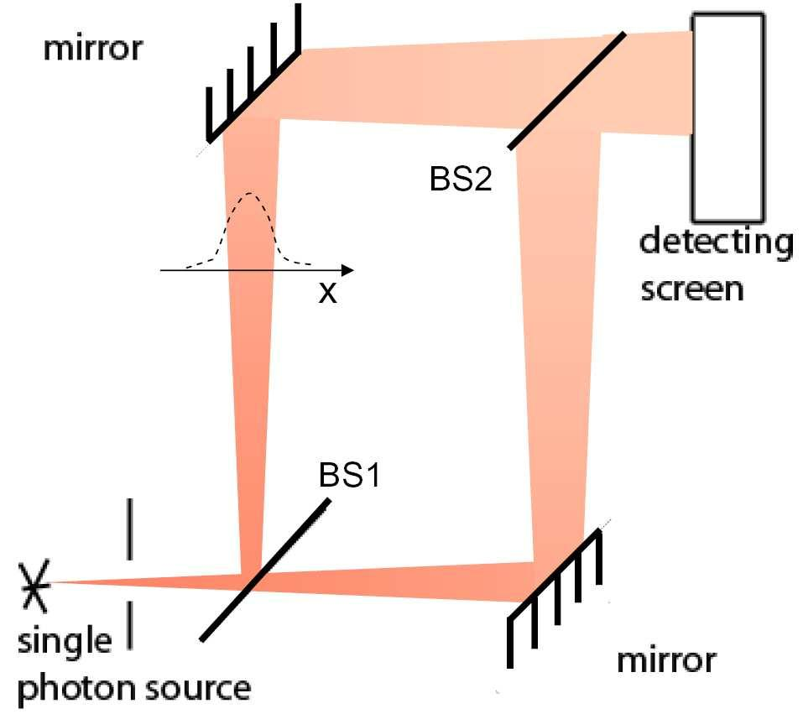

- Student A: Can we tell ahead of time where exactly will a particular photon land on the screen?
- Student B: No. Based upon the path length differences of the contributions from the two paths at different points on the screen, we can only state the probability of a particular photon arriving at a particular point on the screen. When a photon arrives at the screen, this corresponds to a measurement of the photon's position via its interaction with the atoms in the screen. It collapses the state of the photon so that it becomes sharply localized at a point on the screen.
- Student A: It is an interesting model!
- Student B: Yes. After a large number of single photons have arrived at the screen, you can observe the interference pattern reasonably well and compare it with the probability distribution you can calculate from the theoretical model.
Do you agree with Student B?
17. B) Discuss your preceding answer with a partner and explain your reasoning.

- Checkpoint:
- A single photon can be thought of as consisting of many rays (or paths), with a transverse Gaussian profile.
- The various paths of the photon through MZI have phase differences which may yield constructive or destructive interference at different points on the screen, creating an interference pattern on the screen.

- A) Consider the following conversation between Student C and Student D:
- Student C: A single screen (a planar detector e.g., a CCD array) is used in this simulation in place of the point detector D1. If a second screen was introduced in place of the point detector D2, the interference pattern on the second screen after a large number of photons have arrived would not be correlated with the one we observe on the first screen since we cannot predict where the photons will land on the screens.
- Student D: I disagree. The pattern on the two screens will be complementary. If we superimpose the interference patterns on the two screens, the overall intensity will approximately have a Gaussian distribution about the center.
With whom do you agree?
18. B) Discuss your preceding answer with a partner and explain your reasoning.

- A) Consider the following conversation between Student A and Student B:
- Student A: I don’t understand why the Gaussian profile representing the single photon in the figure is getting wider as the photon gets further away from the source where it was produced. The Gaussian profile should maintain the same width, even if the photon propagates from the source.
- Student B: The Gaussian profile representing the single photon broadens because all Gaussian beams diverge over time, whether they are classical or quantum mechanical.
With whom do you agree?
(a) Student A
(b) Student B
- Neither
19. B) Discuss your answer to the preceding question with a partner and explain your reasoning.

Summary: A single photon has a transverse Gaussian profile (Note: We will use this description of a photon with a transverse Gaussian profile only for understanding the interference pattern on the screen in the simulation. For all theoretical questions, including questions on the pre-test and post-test, you can assume that the photon beam is highly collimated so that the width of the transverse Gaussian profile can be ignored.)
- A single photon can be thought of as consisting of many rays (or paths), with a transverse Gaussian profile.
- The various paths of the photon through MZI have phase differences which may yield constructive or destructive interference at different points on the screen, creating an interference pattern on the screen.
- Both the screens (or point detectors D1 and D2) are complementary: when one screen (or detector) shows constructive interference at the center, the second screen (or detector) shows destructive interference at the center.
- Note: The simulation uses a transverse Gaussian profile to represent a single photon so that it is easy to observe the interference pattern without inserting a phase shifter and observing changes, e.g., as a function of the thickness of the phase shifter. However, in all the discussions below about a large number of photons ($N$) emitted from the source, assume that the beam of photons is highly collimated (so that the transverse width of each photon can be ignored) to calculate the number of photons reaching each detector. When playing with the simulation, ignore the number of photons arriving at the screen because all of the questions you are asked about the number of photons arriving at a detector (or screen) are for the highly collimated beam case.

 | Highly collimated beam of photons | Each photon has a transverse Gaussian profile (simulation)
MZI setup given |  | 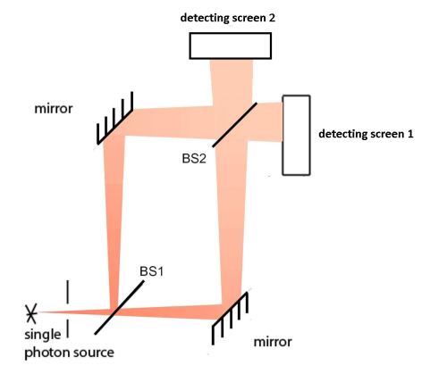
Completely constructive interference at D1 or at the center of detecting screen 1 | Point detector D1 registers a photon 100% of the time (it clicks 100% of the time). | 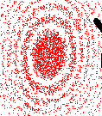 (black spots indicate photon arrival)
Completely destructive interference at D2 or at the center of detecting screen 2 (placed where detector D2 is located) | Point detector D2 never registers a photon (it never clicks). | 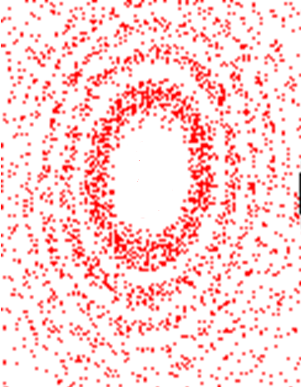
Source emits a large number of photons ($N$) | Point detector D1 registers $N$ photons.  Point detector D2 registers no photon. | Screen 1 Screen 2  A superposition of the two patterns on screen 1 and screen 2 will show an overall intensity with a Gaussian profile.

Case 2: Adding or removing (photo) detectors in the U or L paths
Note: The (photo) detectors are ideal.
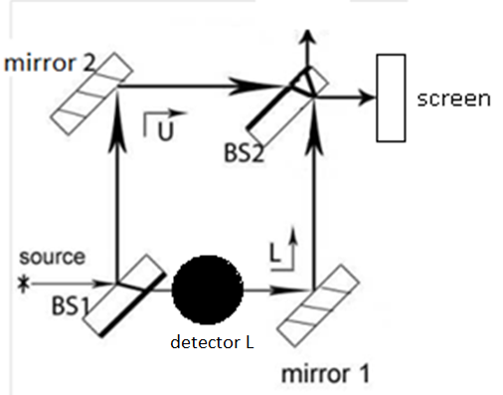

Schematic of MZI with detector L

Now we will explore how inserting additional (photo) detectors in the U and/or L paths can yield information about which path the photon went through (“which-path” information) and destroy the interference pattern observed on the screen. A photo-detector absorbs the photons that it detects. We will continue to replace point detector D1 with a screen, as shown in the simulation. In the computer simulation:

- Switch off the source. Select detector 1 from the instrument menu in the lower left hand corner. Notice that detector 1 gets placed between beam splitter 1 and mirror 1.
- Select detector 2 from the instrument menu in the lower left hand corner. Notice that detector 2 gets placed between mirror 2 and beam splitter 2.
- After examining the locations of the detectors, remove the detectors by unclicking on each of them in the instrument menu.
- Instead of the “lamp” which is a single photon source, you can also select “laser” to obtain the pattern observed on the screen quickly. However, for a given arrangement of the MZI, the “single photon” lamp will give qualitatively similar patterns on the screen for a given set up. By using the speed button you can speed up the emission of single photons from the lamp and obtain the pattern on the screen quickly.

- A) If you insert detector L (or detector 1 in the simulation) in the lower path and turn on the laser or single photon source, what do you expect to observe on the screen compared to the case without detector L (see figure above)?
(a) The interference pattern is unchanged.
(b) The interference pattern vanishes.
(c) The interference pattern becomes easier to discern due to increased contrast.
(d) The interference pattern becomes harder to discern due to reduced contrast.
20. B) Explain your reasoning for the preceding question.

20. C) Consider the following conversation between two students:
- Student A: There is a finite probability that a photon will transmit through detector L, and thus the photon remains in a superposition state of both paths (simultaneously in the U and L paths). Thus, we could observe interference even if detector L is present.
- Student B: I disagree with you. If detector L clicks, the photon is absorbed by detector L and that photon never arrives at the screen. If detector L doesn’t click, the state of the photon collapses such that the photon is no longer in the superposition of the U and L paths. The photon is now only in the U path. Thus, we have “which-path” information about all of the photons that arrive at the screen and we will not observe interference.
With whom do you agree? Explain.

- Go to the simulation. Select detector 1 (which corresponds to detector L in the figure above). Either choose the laser or choose the single photon source. If you choose the single photon source, click on the source button and the speed button to increase the photon count to 4000. Do you observe an interference pattern? Does it agree with your answer to question 20? Discuss your result with a partner and reconcile any differences between your prediction in question 20 and what you observe.

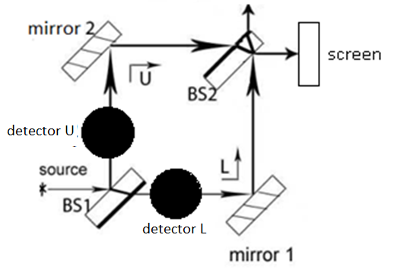

- A) If you insert both detectors L and U (detector 1 and detector 2 in the simulation) and turn on the single photon source, what do you expect to observe on the screen (see figure above)?
  - The interference pattern is unchanged.
  - The interference pattern vanishes and the screen is uniformly illuminated.
  - The interference pattern becomes harder to discern due to decreased contrast.
  - No photons reach the screen.
21. B) Explain your reasoning for the preceding question.

- Go to the simulation. Select both detectors 1 and 2 (which correspond to detector L and U, respectively, as shown in the figure above). Turn on the laser or single photon source. Do you observe an interference pattern? Does it agree with your answer to question 21? Discuss your result with a partner and reconcile any differences between your prediction in question 21 and what you observe.

- Checkpoint:
- If the photo-detector placed in the U or L path registers a photon, the photon state collapses such that the photon gets absorbed by the detector.
- If the photo-detector does not register a photon, the photon state collapses such that the photon takes the other path (the path in which there is no detector) and will show up on one of the screens at the end.
- If a photo-detector is placed in either the U or L path and a large number ($N$) of photons are emitted from the source, $N/2$ of the photons will be absorbed by the photo-detector and $N/4$ will reach the screen shown (and $N/4$ will reach the screen not shown).
- The act of inserting a detector either in the upper or lower path collapses the photon state and gives “which-path” information about whether the photon arriving at the screen took the U or L path of MZI.

- Interaction-free Measurement: Detecting the presence of a photo-sensitive bomb without light ever reaching it

- Consider the situation in which the photon source emits a highly collimated beam of single photons (ignore the width of the transverse Gaussian profile). Detector L is replaced with a photo-detecting bomb, as shown below. If the bomb registers a photon, it detonates. The MZI is set up such that there is completely constructive interference at detector D1 if there was no bomb.
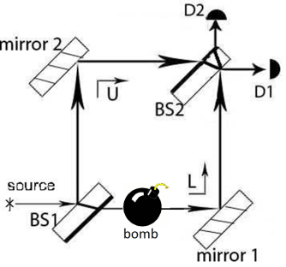

- If we send single photons from the source, what is the probability that the bomb will detonate?

- If we send single photons from the source, what is the probability that the final detector D1 will register a photon (see figure above)?

- If we send single photons from the source, what is the probability that the final detector D2 will register a photon (see figure above)?

- What is the probability that you detect a bomb placed in the L path without the bomb detonating?

- Consider the following conversation between two students about the preceding question:
- Student A: I think that there is a 50% chance that we will be able to detect the bomb without any light ever reaching and detonating it. There is a 50% chance of the bomb detonating (when the bomb is encountered, the probability that the photon state will collapse to the L path state and the bomb will detonate is 50%). Thus, there must be a 50% chance that the bomb will not detonate and the photon takes the U path and is registered at detector D1. But we will not know that a bomb is present if the bomb does not detonate because in the absence of a bomb, all photons arrive at detector D1 anyway where constructive interference takes place.
- Student B: I agree that there is a 50% chance that the bomb will detonate. However, if the bomb does not detonate, the state of the photon has collapsed to the U path state and we have “which-path” information about the photon. We will not observe interference, and there is an equal probability that detector D1 or D2 will click, regardless of the phase difference between the U and L paths. If detector D1 registers a photon, we don’t know whether there is a bomb in the L path, since we have constructive interference at D1 without the bomb. However, if detector D2 clicks (with 25% probability), we know that the bomb is present because without the bomb, detector D2 should never register a photon since there is destructive interference taking place at D2 according to our original setup without the bomb.
- With whom do you agree? Explain. (This situation is an example of what is called an “interaction-free measurement” because the presence of a bomb can be detected without light ever reaching it and detonating it. This is known as the Elitzur–Vaidman bomb tester thought experiment: Elitzur A. C. and Vaidman L. (1993). Quantum mechanical interaction-free measurements. Foundations of Physics. 23, 987-97. arxiv:hep-th/9305002)

Summary: Case 2-How inserting an additional (photo) detector in either the U or L paths can give “which path” information, destroying the interference pattern at the detectors
- If the photo-detector placed in the U or L path registers a photon, the photon state collapses such that the photon gets absorbed by the detector.
- If the photo-detector does not register a photon, the photon state collapses such that the photon takes the other path (the path in which there is no detector) and will show up at one of the two point detectors D1 or D2 (or screens which act as planar detectors) after BS2 with equal probability.
- The photo-detector, when placed either in the upper or lower path, gives “which-path” information about whether the photon that arrives at the point detector D1 or D2 (or the screen that acts as a planar detector ) after BS2 took the U or L path of MZI.
- With a photo-detector inserted in one of the paths, the state of the photon arriving at the point detector D1 or D2 (or the screen which acts as a planar detector) after BS2 is no longer in a superposition of the upper and lower paths. We have “which-path” information for the photons not absorbed by the detector in either the U or L path which arrive at the point detectors D1 or D2 (or screens which act as planar detectors), and the interference pattern is destroyed.
- “Interaction-free measurement”: Due to “which-path” information in the presence of a bomb, the interference of a photon with itself is destroyed and the presence of the bomb can be detected without light ever reaching and detonating it
- Note: Placing photo-detectors in both the U and L paths prevents any photons from reaching the screen (each photon is absorbed by one of the two photo-detectors).

 | Highly collimated beam of photons | Each photon has a transverse Gaussian profile (simulation)
MZI set up given
Source emits a large number of single photons ($N$)
Insert a detector in L path | - “Which-path” information known for all photons  - When a photon is registered at the detector in the L path, it gets absorbed. Approximately $N/2$ photons are absorbed by detector in L path.  - If a photon is not registered at the detector in the L path, it must be in the U path. $N/2$ photons take the U path.  - Since the photon from the U path shows no interference, there is a 25% probability of the photon registering in D1 or D2. D1 registers approximately $N/4$ photons and D2 registers $N/4$ photons. | (black dots indicate photon arrival)  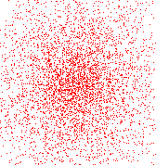  No interference pattern on either detecting screen 1 or 2.
Insert a detector in U path | - “Which-path” information known for all photons  - When a photon is registered at the detector in the U path, it gets absorbed. $N/2$ photons are absorbed by detector in U path.  - If a photon is not registered at the detector in the U path, it must be in the L path. $N/2$ photons take the L path.  - Since the photon from the L path shows no interference, there is a 25% probability of the photon registering in D1 or D2. D1 registers $N/4$ photons and D2 registers $N/4$ photons. | 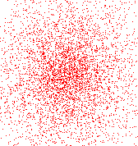  No interference pattern on either detecting screen 1 or 2.

To summarize your single photon results with MZI setup after a large number ($N$) of photons have been emitted from the source, fill out the following table. Assume each photon consists of a highly collimated beam with negligible width of its transverse Gaussian profile.
MZI setup | Do you have “which-path” information for any photons arriving at the detectors D1 or D2? If so, for what fraction? | Probability that detector D1 clicks | Probability that detector D2 clicks
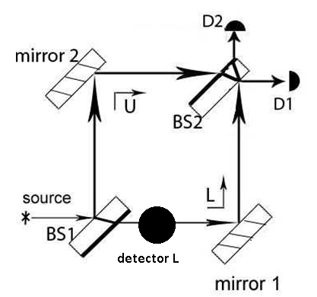Photo-detector in L path
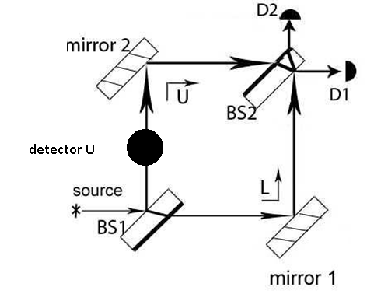Photo-detector in U path
No BS2
Original MZI setup

- In the simulation, remove detectors 1 and 2 by unclicking them in the instrument menu.

Case 3: Adding polarizers in the U and L paths
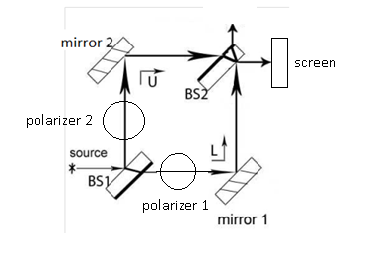

Schematic of MZI with polarizers 1 and 2

Now we will explore how using polarizers in the U and/or L paths can yield “which-path” information about some or all of the photons arriving at the screen and destroy the interference pattern (or reduce the contrast on the screen if some photons show interference and others do not). We will continue to replace point detector D1 with a screen, as shown in the simulation. In the computer simulation:
- Switch off the source. Select polarizer 1 from the instrument menu in the lower left hand corner. Notice that polarizer 1 gets placed between mirror 1 and beam splitter 1. Try changing the polarization axis of the polarizer by grabbing the protruding knob on the polarizer and rotating it. On the lower left hand corner in the instrument menu, you can read the angle made by the transmission axis.
- Select polarizer 2 from the instrument menu in the lower left hand corner. Notice that polarizer 2 gets placed between mirror 2 and beam splitter 2.
- Select polarizer 3 from the instrument menu in the lower left hand corner. Notice that polarizer 3 gets placed between beam splitter 2 and the screen.
- After examining the locations of the polarizers, get rid of them by unclicking on each in the instrument menu.
- Instead of the “lamp” which is a single photon source, you can also select “laser” to obtain the interference pattern quickly on the screen. However, for a given arrangement of the MZI, the “single photon” lamp will give qualitatively similar interference patterns. By using the speed button you can speed up the emission of single photons from the lamp.

Case 3.1: Effect of adding polarizers when the source emits unpolarized single photons

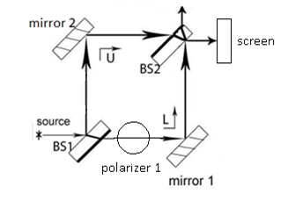
Note: For questions 23-32, assume that the photon state is unpolarized. In the unpolarized single photon state, half of the photons can be considered to be polarized along one direction and the other half of the photons perpendicular to it (e.g., half polarized vertically and the other half polarized horizontally or half polarized at 45° and the other half at -45°). In the simulation, ignore the number of photons that register at the screen because in all of the questions asking you to predict the number of photons arriving at the detectors D1 or D2, you should assume that the photon beam is highly collimated so that the width of its Gaussian profile can be ignored (unlike the simulation).

- Consider the following conversation between two students:
- Student 1: For an unpolarized beam of light, the polarization is completely random. If a polarizer is placed in the path of the beam, then half of the light goes through, regardless of the polarization angle.
- Student 2: I agree. And for an unpolarized source of single photons, if a polarizer is present, half of the photons go through and the other half get absorbed, regardless of the polarization angle. If we are given polarizers with a certain polarization angle, we can use that polarization angle to choose a suitable basis. A good choice of basis consists of polarization states of the photon parallel and perpendicular to the polarization axis of the polarizer. This basis would make the analysis of the situation simpler.
- Student 1: Yes, and in the basis that consists of the polarization states of the photon parallel and perpendicular to the polarization axis, half of the unpolarized photons can be considered to be polarized parallel to the polarization axis and half can be considered to be polarized perpendicular to the polarization axis.
Do you agree with Student 1 and Student 2? Explain your reasoning.

- A) Choose all of the following statements that are true about what happens when you insert polarizer 1 with a horizontal polarization axis in path L and turn on the unpolarized single photon source (see figure above):
- The photons with horizontal polarization will form an interference pattern.
- The photons with vertical polarization will not form an interference pattern because we have “which-path” information for those photons.
- The interference pattern will be harder to discern due to reduced contrast on the screen because only photons with horizontal polarization form an interference pattern.

  - (I) and (II) only
  - (I) and (III) only
  - (II) and (III) only
  - All of the above.
24. B) Explain your reasoning for the preceding question.
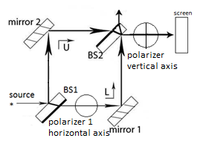
- A) Consider the following conversation between Student A and Student B:
- Student A: Consider placing an additional polarizer with a vertical transmission axis right before the screen, as shown. If the photon goes through this vertical polarizer and we observe a flash on the screen, the photon is vertically polarized and must have gone through the upper path. These vertically polarized photons will not show interference since we have “which-path” information about them.
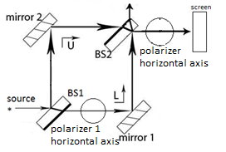
- Student B: I agree with you. On the other hand, if we place an additional polarizer with horizontal transmission axis right before the screen (as shown) and observe a flash on the screen, this photon arriving at the screen was horizontally polarized and we do NOT have “which-path” information about that photon. Even though there is a horizontal polarizer in the L path, the state of this horizontally polarized photon is a superposition of the U and L path states and we will observe interference for these horizontally polarized photons.
With whom do you agree?
- Student A
- Student B
- Both Student A and Student B
- Neither
25. B) Explain your reasoning for the preceding question.

25. C) Consider the following conversation between Student C and Student D:
  - Student C: Do we need to have a vertical polarizer right in front of the screen to measure the polarization of the photon arriving at the screen in order to have “which-path” information (and not observe interference), e.g., for the case that Student A is describing in question 25.A?
  - Student D: No. So long as theoretically we can justify that the polarization of the photon is known when it arrives at the screen and will give us information about the path that the photons took, we will not observe an interference pattern.
  - Student E: I agree with Student D. Even without the second polarizer placed before the screen, in both figures in question 25.A, we can assert that if there is a horizontal polarizer in the L path the photons arriving at the screen that show interference must be horizontally polarized and those that do not show interference must be vertically polarized.
Do you agree with Student D and E?

25. D) Explain your reasoning for the preceding question.

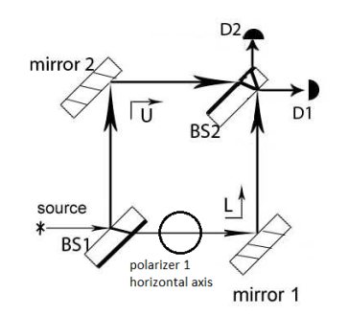

- Consider the following conversation between two students about the figure above when the source emits unpolarized photons (assume a highly collimated beam of photons is emitted from source):
- Student A: If the source emits $N$ unpolarized photons, a suitable basis for this case consists of photon states with horizontal polarization and vertical polarization. Since the source is emitting unpolarized photons, we can assume the following after a large number of photons ($N$) have been emitted from the source:
- Before entering BS1, approximately $N/2$ photons are vertically polarized and $N/2$photons are horizontally polarized.
- After exiting BS1, approximately $N/4$ vertically polarized photons in the L path are blocked by polarizer 1, which has a horizontal transmission axis. The rest of the $N/4$ vertically polarized photons that arrive at the screens must have come via the U path.
- After exiting BS1, approximately $N/2$ horizontally polarized photons can remains in a state which is a superposition of the U and L path states, despite the presence of a horizontal polarizer in the L path.
- Student B: So that means we have “which-path” information about approximately $N/4$ vertically polarized photons when they arrive at the detectors. Since we have “which-path” information for these vertically polarized photons, they don’t display interference and they have equal probability of registering at either detector D1 or D2 in the figure above. Therefore, approximately $N/8$ photons end up at detector 1 and $N/8$ photons end up at detector 2.
- Student A: I agree with you. And we don’t have “which-path” information about the horizontally polarized photons that can be in a superposition state of the U and L paths when they arrive at detector 1. Therefore, approximately $N/2$ horizontally polarized photons will arrive at detector D1 since that detector corresponds to completely constructive interference. This diagram shows an approximate description:
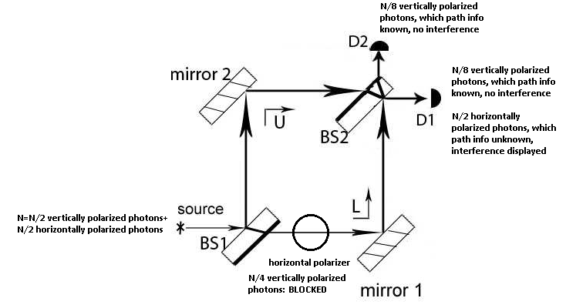

Do you agree with Student A and Student B? Explain your reasoning.

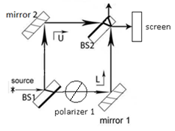

27. A) Consider the following conversation between three students:
- Student A: Since the photons coming from the source are unpolarized, half of the photons from the source are horizontally polarized and half of the photons are vertically polarized. If we insert polarizer 1 with a +45° polarization axis (see figure above), we will not have “which-path” information about any of the photons.
- Student B: I disagree. The source is emitting photons which are unpolarized, so we can assume that approximately half of the photons coming from the source are +45° polarized, and half of the photons are 315° (-45°) polarized. We will have “which-path” information about the photons that are -45° polarized when they arrive at the screen since we know that the -45° polarized photons will be blocked by polarizer 1 (which has a +45° polarization axis) in the lower path.
- Student C: I agree with Student B. This case is analogous to the case in question 26 in which polarizer 1 had a horizontal polarization axis. Here, all of the photons with -45° polarization arriving at the screen must be from the U path in which there is no polarizer. These photons will not show an interference pattern at the screen unlike the photons with +45° polarization for which we do not have “which-path” information. Since we don’t know which path the photons with +45° polarization took, the state of these photons can be in a superposition of the U and L paths and therefore they will display interference.
With whom do you agree? (You can agree with more than one student.)
- Student A
- Student B
- Student C
- Neither
27. B) Explain your reasoning for the preceding question.

27. C) Do you expect the interference pattern on the screen shown above to be easier or harder to discern compared to the situation when polarizer 1 was not present? Explain.

- Go to the simulation. Select polarizer 1 from the instrument menu. Turn on the laser. Do you observe an interference pattern? Is the pattern more or less sharp compared to the case when polarizer 1 was not present? Does your answer agree with your answer to question 27? Does the polarization axis of polarizer 1 matter (would you have obtained the same answer regardless of the polarization axis of the polarizer)? Discuss your result with a partner and reconcile any differences between your prediction in question 27 and what you observe.

- Checkpoint:
  - For a source emitting a large number ($N$) of unpolarized photons, if only one polarizer is added in the U or L paths:
    - $N/4$ photons are absorbed by the polarizer.
    - We will have “which-path” information for approximately $N/4$ of the photons (photons with polarization orthogonal to the polarization axis of the polarizer) arriving at the screens, and these photons will not show an interference pattern on the screen.
    - We will not have “which-path” information for $N/2$ of the photons with polarization parallel to the polarizer.
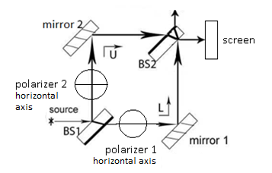

- A) If you insert polarizers 1 and 2 both with horizontal polarization axes (see figure above) and turn on the unpolarized laser source, what do you expect to observe on the screen after a large number of photons ($N$) reach the screen? Assume the source emits a highly collimated beam of photons.
(a) The pattern is identical to the case in which we used only polarizer 1.
(b) The interference pattern vanishes but approximately ¼^{th} of the photons reach the screen shown.
(c) The interference pattern becomes sharper (easier to discern) compared to the case when we used only polarizer 1.
(d) No photons reach the screen.
28. B) Explain your reasoning for the preceding question.

28. C) Discuss with your partner approximately how many photons out of a very large number$N$ (assume that the source emits a highly collimated beam of photons), each with vertical and horizontal polarization, will end up at detector D1 or detector D2.
Hint: Since the photon source is unpolarized, assume that approximately half of the incoming photons are horizontally polarized ($N/2$) and half are vertically polarized ($N/2$). Photons for which you have “which-path” information do not show interference and can arrive at either detector with equal probability.

- In the simulation, select polarizers 1 and 2, both with horizontal polarization axes. Run the simulation. Do you observe any change in the interference pattern compared to the case when only polarizer 1 was present? Does it agree with your answer to question 28? Discuss your result with a partner and reconcile any differences between your prediction in question 28 and what you observe
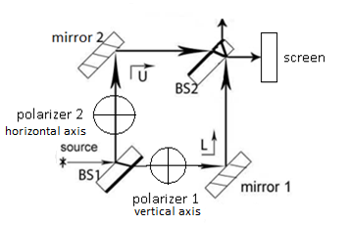

- A) If you insert polarizer 1 with a vertical polarization axis and polarizer 2 with a horizontal polarization axis (see figure above) and turn on the unpolarized laser source or single photon source, what do you expect to observe on the screen after a very large number of photons ($N$) have been emitted from the source? Assume the source emits a highly collimated beam of photons.
(a) The pattern is identical to the one with only polarizer 1 present.
(b) The interference pattern vanishes but approximately ¼^{th} of the photons reach the screen shown.
(c) The interference pattern becomes sharper (easier to discern) compared to the case when we used only polarizer 1.
(d) No photons reach the screen.
29. B) Explain your reasoning for the preceding question.

- In the simulation, select both polarizers 1 and 2, but one with a horizontal and the other with a vertical polarization axis. Run the simulation. Do you observe any change in the interference pattern compared to the case when only polarizer 1 was present? Does your answer agree with your answer to question 29.A? Discuss your result with a partner and reconcile any differences between your prediction in question 29.A and what you observe.

29. C) Consider the following statement by student A about the MZI setup shown above:
- Student A: To understand what we observe at the screens when the source emits unpolarized single photons, we can consider the source emitting an equal number of vertically polarized photons and horizontally polarized photons separately. Then, we can average over what we observe at the screens (or detectors) to predict what we would observe for unpolarized photons. Like this:
1. If we send a large number of vertically polarized photons ($N$), $N/2$ of them will be blocked by polarizer 2 in the upper path, since it has a horizontal polarization axis. $N/2$ of the photons will pass through polarizer 1, and we have “which-path” information for those photons. Thus, $N/4$ vertically polarized photons will arrive at the screen shown. $N/4$ photons for which we have “which-path” information will arrive at the screen not shown.
2. If we send a large number of horizontally polarized photons ($N$), $N/2$ of them will be blocked by polarizer 1 in the lower path, since it has a vertical polarization axis. $N/2$of the photons will pass through polarizer 2, and we have “which-path” information for those photons. Thus, $N/4$ horizontally polarized photons will arrive at the screen shown. $N/4$ photons for which we have “which-path” information will arrive at the screen not shown.
3. Averaging over the two photon polarizations, we observe the following at the screen shown when a large number ($N$) of unpolarized photons are sent one at a time through the setup shown below:
($N/4$ vertically polarized photons + $N/4$ horizontally polarized photons)/2 = $N/4$ unpolarized photons. Thus, we would expect to see $N/4$ unpolarized photons, which do not display interference, arriving at the screen shown (and the other $N/4$ photons will arrive at the screen not shown).
Do you agree with Student A? Explain your reasoning.

29. D) Consider the following conversation between two students about the MZI setup shown above:
- Student B: We can send an equal number of vertically polarized photons and horizontally polarized photons separately and average the results to predict what we observe on the screen for unpolarized photons. What if, instead, we send a large number ($N$) of +45° polarized photons and -45° polarized photons, each in equal proportion? Can we still average over the results to predict what we should observe for unpolarized photons emitted by the source?
- Student A: Yes. You can think of it this way:
1. Suppose we send a large number ($N$) of +45° polarized photons. $N/4$ of those photons are blocked by the horizontal polarizer and $N/4$ of them are blocked by the vertical polarizer. We have “which-path” information for all of these photons, so $N/8$ vertically polarized photons and $N/8$ horizontally polarized photons arrive at the screen shown above.
2. Suppose we send a large number number ($N$) of -45° polarized photons. $N/4$ of those photons are blocked by the horizontal polarizer and $N/4$ of them are blocked by the vertical polarizer. We have “which-path” information for all of these photons, so $N/8$ vertically polarized photons and $N/8$ horizontally polarized photons arrive at the screen shown above.
3. There are a total of $N/4$ horizontally polarized photons and $N/4$ vertically polarized photons which arrive at the screen shown. Thus, averaging over the photon polarizations, we observe the following at the screen shown when unpolarized photons are sent one at a time:
($N/4$ vertically polarized photons + $N/4$ horizontally polarized photons)/2 = $N/4$ unpolarized photons. We expect $N/4$ unpolarized photons, which do not display interference, arriving at the screen shown.
- Student B: So it doesn’t matter whether we think of the unpolarized source emitting an equal mixture of horizontally and vertically polarized photons or an equal mixture of +45° and -45° polarized photons. We would still see the same pattern on the screen shown.
- Student A: That is correct. However, it is easier to reason about unpolarized photons considered as an equal mixture of two orthogonal polarized photon states such that the polarizations correspond to the polarization axes of the polarizers in the MZI setup.
Do you agree with Student A and Student B? Explain your reasoning.

- Checkpoint:
  - If we place polarizers in each of the U and L paths and if polarizers 1 and 2 in those paths are orthogonal, we have “which-path” information for all of the photons arriving at the screen, and the interference pattern will vanish.

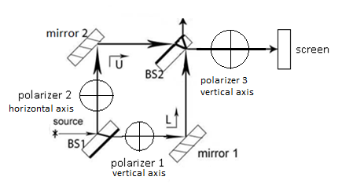

- A) You insert polarizer 1 with a vertical polarization axis and polarizer 2 with a horizontal polarization axis. You also insert polarizer 3 with a vertical polarization (see figure above). When you turn on the unpolarized laser source, what do you expect to observe on the screen after a very large number of photons ($N$) are emitted from the source? Assume the source emits a highly collimated beam of photons.
- The interference pattern is present and it is identical to the case when we used only polarizers 1 (horizontal axis) and polarizer 2 (vertical axis).
- There is no interference pattern but approximately 1/8th of the photons coming from the source reach the screen shown.
- An interference pattern reappears that was absent when we only used polarizer 1 (horizontal axis) and polarizer 2 (vertical axis).
- No photons reach the screen.
30. B) Explain your reasoning for the preceding question.

- In the simulation, select polarizers 1 and 2, one with a horizontal and the other with a vertical polarization axis. Select polarizer 3 with a vertical polarization. Run the simulation. Do you notice any change in the interference pattern compared to when polarizer 3 was not present? Does it agree with your answer to question 30? Discuss your result with a partner and reconcile any differences between your prediction in question 30 and what you observe.

- Consider the following conversation between Student A and Student B:
  - Student A: In question 29, we have “which-path” information for the photon arriving at the screen when we place a horizontal polarizer in one path and a vertical polarizer in the other path. Therefore, no interference is observed. If a photon arrives at the screen with vertical polarization, it must have come from only the L path. If a photon arrives at the screen with horizontal polarization, it must have come from the U path.
  - Student B: I agree. Also, if we place polarizer 3 with a vertical polarization axis right before the screen (like in the figure above), polarizer 3 only blocks the horizontally polarized photons from the upper path from reaching the screen. Only vertically polarized photons from the lower path will reach the screen. However, since we have “which-path” information for all the photons in this case, no interference is observed on the screen.
Explain why you agree or disagree with each student.

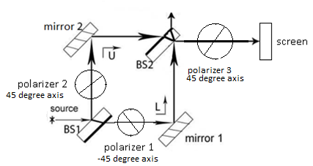

- A) You insert polarizer 1 with a -45° polarization axis and polarizer 2 with a +45° polarization axis. You also insert polarizer 3 with a +45° polarization axis. When you turn on the unpolarized laser source, what do you expect to observe on the screen after a very large number of photons ($N$) reach the screen? Assume the source emits a highly collimated beam of photons.
- The interference pattern is present and it is identical to the case when we used only polarizer 1 (-45° axis) and polarizer 2 (+45° axis).
- There is no interference pattern but approximately 1/8th of the photons coming from the source reach the screen.
- An interference pattern reappears that was absent when we only used polarizer 1 (-45° axis) and polarizer 2 (+45° axis).
- No photons reach the screen.
32. B) Explain your reasoning for the preceding question.

- In the simulation, select polarizers 1 with a -45° polarization axis and polarizer 2 with a +45° polarization axis. Select polarizer 3 with a 45° polarization axis. Run the simulation. Do you notice any change in the interference pattern compared to when polarizer 3 was not present? Does it agree with your answer to question 32? Discuss your result with a partner and reconcile any differences between your prediction in question 32 and what you observe.

Case 3.2: Effect of adding polarizers when the source emits 45° polarized single photons
Case 3.2.1: 45° polarized single photons emitted by the source and polarizers with horizontal or vertical polarization axes in the U and L paths
- Now suppose the source emits 45° polarized single photons (which can be thought of as an equal superposition of horizontal and vertical polarization states, e.g., $\left|45\right.°〉=\frac{\left|H\right.〉+\left|V\right.〉}{\sqrt{2}})$ as opposed to unpolarized single photons (which can be thought of as a mixture with half of the photons with one polarization and the other half with a polarization orthogonal to it, e.g., half of the photons with +45° polarization and the other half with -45° polarization OR half of the photons with horizontal polarization and the other half with vertical polarization).
- In all of the following questions, since we are dealing with photon polarization, we will assume that each detector D1 and D2 is covered with a polarizer with a certain polarization so that each photon detected has a certain polarization.
- In questions involving photon path and polarization states:

$$\left|U\right.〉=photon state in upper path$$
$$\left|L\right.〉=photon state in lower path$$
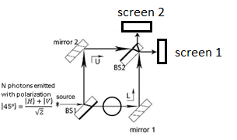
$$\left|V\right.〉=photon in vertical polarization state$$
$$\left|H\right.〉=photon in horizontal polarization state$$

- A) Choose all of the following statements that are true about what happens when you insert
polarizer 1 with a horizontal polarization axis in path L and turn on the 45° polarized single photon source (see figure above) and a large number of photons ($N$) are sent one at a time (Assume the source emits a highly collimated beam of photons.):
- Approximately $N/4$ photons will get absorbed by the horizontal polarizer in the L path.
- Out of the photons that propagate through BS2, $N/4$ photons do not show interference and have equal probability of arriving at either screen 1 or screen 2.
- The photons with a horizontal polarization component will form an interference pattern because we do not have “which-path” information for those photons.
- The interference pattern will be harder to discern due to reduced contrast at screen 1.

- (I) and (II) only
- (I) and (III) only
- (I), (II) and (III) only
- All of the above.
33. B) Explain your reasoning for the preceding question.
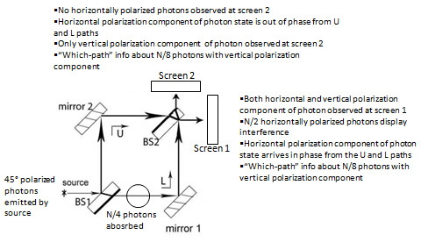

34. Consider the following conversation between two students:
  - Student 1: How is the case in which the source emits 45° polarized single photons different from the case in which the source emits unpolarized photons? Will the interference pattern be different for the figure shown above if the source emits 45° polarized single photons instead of unpolarized photons?
  - Student 2: We can think of a 45° polarized photon as a superposition of horizontal and vertical polarizations, e.g., $\left|45\right.°〉=\frac{\left|H\right.〉+\left|V\right.〉}{\sqrt{2}}$. The source emitting a superposition is NOT equivalent to a source emitting an equal mixture of horizontally and vertically polarized photons, as in the case for unpolarized photons emitted by the source. If the source emits 45° polarized photons:
- The photon state after exiting the horizontal polarizer in the L path in the figure above must only have a horizontal polarization component in the L path.
- The 45° polarized photon state emitted by the source in the upper path in the figure above is a superposition of both vertical and horizontal polarization components.
- We have “which-path” information about a photon with a vertical polarization component arriving at the screens because we know it could not have come from the lower path. We don’t have “which path” information about a photon with a horizontal polarization component because it could have come from either the U or L path.
- If a horizontal polarizer is placed in front of screen 1, the horizontal polarization component of the photon state arrives in phase from the U and L paths. Thus, the horizontal component of the photon state leads to constructive interference at screen 1 and no vertically polarized photons would reach screen 1. If a vertical polarizer is placed in front of screen 1, the horizontal component of the photon state is blocked and only vertically polarized photons reach screen 1 and do not show interference.
- If a horizontal polarizer is placed in front of screen 2, the horizontal polarization component of the photon arrives out of phase from the U and L paths and the horizontal components of the photon state display destructive interference, so no horizontally polarized photons arrive there. No vertically polarized photons would reach screen 2. If a vertical polarizer is placed in front of screen 2, the horizontal component of the photon state is blocked and only vertically polarized photons reach screen 2 and do not show interference.
- If the source emits a large number $N$ of photons, the diagram shown above will help you visualize how many photons reach each detector.
Do you agree with Student 2’s explanation? Explain.
- Checkpoint: For a source emitting 45° polarized single photons, if only one polarizer is added in either the U or L path:
  - With a horizontal or vertical polarization axis, we will have “which-path” information about ¼ of the photons (with a polarization component orthogonal to the polarization axis of the polarizer) arriving at the screens, and those photons will not show an interference pattern on the screen. However, we will not have “which-path” information for ½ of the photons that arrive at the screen with polarization parallel to the polarization axis of the polarizer.

- A) If you insert polarizer 1 with a vertical polarization axis and polarizer 2 with a horizontal polarization axis (see figure below) and turn on the 45° polarized single photon source, what do you expect to observe on screen 1 after a very large number of photons ($N$) have been emitted from the source? Assume the source emits a highly collimated beam of photons.
(a) The interference pattern is identical to the one with only polarizer 1 present.
(b) The interference pattern vanishes but approximately ¼^{th} of the photons reach screen 1.
(c) The interference pattern becomes sharper (easier to discern) compared to the case when we used only polarizer 1.
(d) No photons reach screen 1.
35. B) Explain your reasoning for the preceding question.

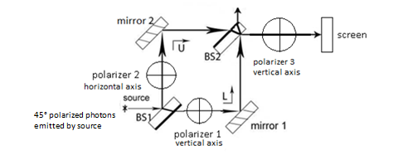

- A) You insert polarizer 1 with a vertical polarization axis and polarizer 2 with a horizontal polarization axis. You also insert polarizer 3 with a vertical polarization (see figure above). When you turn on the 45° polarized single photon source, what do you expect to observe on the screen after a very large number of photons ($N$) are emitted from the source? Assume the source emits a highly collimated beam of photons.
- The interference pattern is present and it is identical to the case when we used only polarizers 1 (horizontal axis) and polarizer 2 (vertical axis).
- There is no interference pattern but approximately 1/8th of the photons coming from the source reach the screen shown.
- An interference pattern reappears that was absent when we only used polarizer 1 (horizontal axis) and polarizer 2 (vertical axis).
- No photons reach the screen.
36. B) Explain your reasoning for the preceding question.

- Checkpoint: For a source emitting 45° polarized single photons:
  - If we place polarizers in each of the U and L paths and if polarizers 1 and 2 in those paths have vertical and horizontal polarization axes, we have “which-path” information for all of the photons arriving at the screen. The interference pattern will vanish regardless of whether the source emits unpolarized single photons or 45° polarized single photons.

Case 3.2.2: 45° polarized single photons emitted by the source and polarizers with +45° or -45° polarization axes in the U and L paths
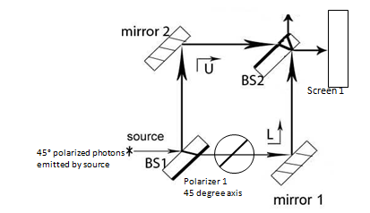

- You insert polarizer 1 with a +45° polarization axis (see figure above). When you turn on the 45° polarized single photon source, what do you expect to observe on the screen after a very large number of photons ($N$) are emitted from the source? Assume the source emits a highly collimated beam of photons.
- No interference pattern is observed but approximately $N/4$ photons reach screen 1.
- An interference pattern is observed, but it is dimmer (harder to discern) than when no polarizers are present.
- An interference pattern is observed, and there is no difference between the pattern observed in the setup shown above and when there are no polarizers present.
- No photons reach the screen.

- Consider the following conversation between two students:
  - Student 1: When polarizer 1 with a horizontal polarization axis is placed in the L path and the source emitted 45° polarized single photons (as in question 34), it is convenient to think of the photon polarization state in the basis of horizontal polarization state $\left|H\right.〉$ and vertical polarization state $\left|V\right.〉$, e.g., $\left|45\right.°〉=\frac{\left|H\right.〉+\left|V\right.〉}{\sqrt{2}}$ to determine the fraction of photons that arrive at the screens. However, in the figure shown above, since the polarization axis of the polarizer is +45°, we don’t have to switch bases to determine how many photons arrive at screen 1.
  - Student 2: I agree with you. Since +45° polarized photons can travel along both the U or L paths, we don’t have “which-path” information for any of the photons. It is as if there were no polarizer there at all (as in the original MZI setup given at the beginning of this tutorial). If the source emits a large number ($N$) of photons, all $N$ photons arrive at screen 1 and display interference.
With whom do you agree? Explain your reasoning.

- You insert polarizer 1 with a -45° polarization axis (see figure above). When you turn on the 45° polarized single photon source, what do you expect to observe on the screen after a very large number of photons ($N$) are emitted from the source? Assume the source emits a highly collimated beam of photons.
- No interference pattern is observed but approximately $N/4$ photons reach screen 1.
- An interference pattern is observed, but it is dimmer than when no polarizers are present.
- An interference pattern is observed, and there is no difference between the pattern observed in the setup shown above and when there are no polarizers present.
- No photons reach the screen.

- Checkpoint: For a source emitting 45° polarized single photons, if only one polarizer is added in either the U or L path:
    - With a +45° polarization axis, we will NOT have “which-path” information about any of the photons arriving at the point detector, and these photons will display interference at the point detector. If the source emits a larger number ($N$) of 45° polarized photons, all $N$ photons will arrive at point detector D1 or screen 1.
    - With a -45° polarization axis, we will have “which-path” information about ALL of the photons arriving at the point detectors, and these photons will not display interference at the point detector. If the source emits a large number ($N$) of 45° polarized photons, $N/2$ photons are absorbed by the polarizer. $N/2$ photons which are not absorbed by the polarizer travel along the other path (in which there is no polarizer) and $N/4$ of these photons arrive at each point detector (or screen) but they do not display interference.

- You insert polarizer 1 with a +45° polarization axis and polarizer 2 with a -45° polarization axis (see figure above). When you turn on the 45° polarized single photon source, what do you expect to observe on the screen after a very large number of photons ($N$) are emitted from the source? Assume the source emits a highly collimated beam of photons.
- No interference pattern is observed, but approximately $N/4$ photons reach screen 1.
- An interference pattern is observed, but it is dimmer than when no polarizers are present.
- An interference pattern is observed, and there is no difference between the pattern observed in the setup shown above and when there are no polarizers present.
- No photons reach the screen.

- A) You insert polarizer 1 with a +45° polarization axis and polarizer 2 with a -45° polarization axis. You also insert polarizer 3 with a +45° polarization axis (see figure above). When you turn on the 45° polarized single photon source, what do you expect to observe on the screen shown? Assume the source emits a highly collimated beam of photons.
- The interference pattern is present and it is identical to the case when we used only polarizer 1 (+45° axis) and polarizer 2 (-45° axis).
- There is no interference pattern but approximately 1/4 of the photons coming from the source reach the screen shown.
- An interference pattern reappears that was absent when we only used polarizer 1 (+45° axis) and polarizer 2 (-45° axis).
- No photons reach the screen shown.
41. B) Explain your reasoning for the preceding question.

Summary: Case 3-Adding polarizers in the U or L paths can give “which path” information, partially or fully destroying interference pattern at the point detectors (or screens)
- The act of adding polarizers in the U or L path of the MZI can yield “which-path” information about some or all of the photons arriving at the screens (or point detectors), depending on the situation.
- If the incoming single photons are unpolarized and if only one polarizer is added in either the U or L path, we will have “which-path” information for approximately $N/4$ photons (photons with polarization orthogonal to the polarization axis of the polarizer) arriving at the screens, and these photons will not display interference at the screens. $N/4$ photons are absorbed by the polarizer. However, we will NOT have “which-path” information for $N/2$ of the photons (photons with polarization aligned with the polarization axis of the polarizer) arriving at the screens, and these photons will display interference at the screens.
- If the incoming single photon is 45° polarized:
  - The incoming photon cannot be considered a mixture of two orthogonal polarizations but a superposition, e.g., of horizontal and vertical polarizations, i.e., $\left|45°\right.〉=\frac{\left|H\right.〉+\left|V\right.〉}{\sqrt{2}}$.
  - If only one polarizer is added in either the U or L path with a horizontal or vertical polarization axis, we will have “which-path” information about $N/4$ of the photons (with a component of polarization orthogonal to the polarization axis of the polarizer) arriving at the screens, and these photons will not display interference at the point detector. $N/4$ photons are absorbed by the polarizer. We will NOT have “which-path” information for $N/2$ photons that have propagated through both paths and these photons display interference at the screens.
  - If only one polarizer is added in either the U or L path with a +45° polarization axis, we will NOT have “which-path” information about any of the photons arriving at the screens, and these photons will display interference at the screens. If the source emits a larger number ($N$) of 45° polarized photons, all $N$ photons will arrive at the screen corresponding to constructive interference.
  - If only one polarizer is added in either the U or L path with a -45° polarization axis, we will have “which-path” information about ALL of the photons arriving at the screens, and these photons will not display interference at the screens. If the source emits a large number ($N$) of 45° polarized photons, $N/2$ photons are absorbed by the polarizer. $N/2$ photons are not absorbed by the polarizer and $N/4$ of these photons arrive at each screen and do not display interference.
  - If we place polarizers in each of the U and L paths and if polarizers 1 and 2 in those paths have orthogonal polarization axes, we have “which-path” information for all of the photons arriving at the screens, regardless of whether the source emits unpolarized or polarized photons.

Case 4: Quantum Eraser

For all cases involving the quantum eraser below, assume the source emits 45° polarized single photons (because as we will discuss later, a quantum eraser setup will distinguish between unpolarized and polarized photons emitted from the source. In particular, a quantum eraser will erase “which-path” information only for polarized photons). For estimating the number of photons arriving at the screens shown after BS2, assume that a highly collimated beam of photons is emitted from the source and ignore the width of the transverse Gaussian profile of the photon.
In questions involving photon path and polarization states:

$$\left|U\right.〉=photon state in upper path$$
$$\left|L\right.〉=photon state in lower path$$
$$\left|V\right.〉=photon in vertical polarization state$$
$$\left|H\right.〉=photon in horizontal polarization state$$

Note: In the simulation, the source adjusts automatically to emit photons with a certain polarization (e.g., 45° or vertical) so that a quantum eraser is observed.

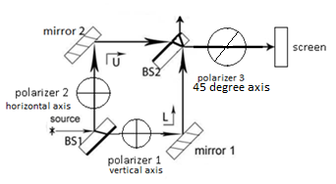

- A) You insert polarizer 1 with a vertical polarization axis and polarizer 2 with a horizontal polarization axis. You also insert polarizer 3 with a 45° polarization axis. When you turn on the 45° polarized single photon source, what do you expect to observe on the screen shown above after a large number ($N$) of photons have been emitted from the source? Assume the source emits a highly collimated beam of photons.
- The pattern is identical to the case when we used only polarizer 1 (horizontal axis) and polarizer 2 (vertical axis).
- There is no interference pattern but some photons reach the screen shown.
- An interference pattern is observed (dimmer than the pattern when no polarizers are used, but otherwise similar). Only approximately 1/4th of the photons emitted from the source arrive at the screen shown and show interference.
- No photons reach the screen.
42. B) Explain your reasoning for the preceding question and discuss explicitly how you found the fraction of photons that will display interference on the screen shown.

42. C) Consider the following conversation between two students:
- Student A: How can you tell that approximately 1/4th of the photons emitted from the source arrive at screen 1 shown in the figure below and show interference?
- Student B: Let me show you a qualitative description of the approximate numbers in a diagram.
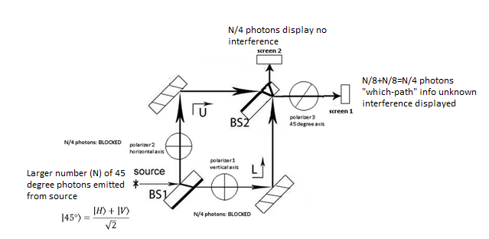
- Student A: Do the photons arriving at screen 2 display interference?
- Student B: No. We have “which-path” information for those photons arriving at screen 2 since there is no 45° polarizer between BS2 and screen 2 and thus there will be no interference displayed in the given case when we have two orthogonal polarizers in the U and L paths. There is interference displayed at screen 1 because polarizer 3 “erases” the “which-path” information for the photons passing through it. Due to polarizer 3, each photon that arrives at screen 1 is in a superposition of vertically and horizontally polarized photon states. Since the phase difference between the two paths in the setup is such that there is constructive interference taking place after BS2, the vertically and horizontally polarized components in the superposition are in phase at the 45° polarizer ($\left|45°\right.〉=\frac{\left|H\right.〉+\left|V\right.〉}{\sqrt{2}}$) so that no photon is absorbed by polarizer 3.
Do you agree with Student B’s diagram and reasoning? Explain.

- In the simulation, select polarizers 1 and 2, one with a horizontal and the other with a vertical polarization axis. In addition, select polarizer 3 with a 45° polarization axis. Run the simulation. Do you observe any change in the interference pattern compared to the preceding case in which only polarizer 1 and 2 were present? Do you observe any change in the interference pattern compared to the preceding cases where polarizer 3 had vertical the same polarization as polarizers 1 and 2? Does it agree with your response to question 42? Discuss your result with a partner and reconcile any differences between your prediction in question 42 and what you observe.

- A) Consider the following conversation between two students:
  - Student 1: When the vertically and horizontally polarized single photons in question 42 go through polarizer 3, which has a +45° polarization axis, why don’t half of the photons that enter polarizer 3 get absorbed?
  - Student 2: You should be careful to distinguish between photons polarized at 45°, whose state can be written as $\left|45°\right.〉=\frac{\left|H\right.〉+\left|V\right.〉}{\sqrt{2}}$ , and unpolarized photons, in which half of the photons can be considered to be vertically polarized and half to be horizontally polarized. The quantum eraser case makes a clear distinction between a superposition and an unpolarized mixture. For the unpolarized mixture, we have “which-path” information for each photon if two orthogonal polarizers are placed in the U and L paths. Polarizer 3 will block half of the incoming unpolarized photons. On the other hand, for +45° polarized photons, a single photon state from the two paths can still be in a superposition, $\frac{\left|L\right.〉\left|H\right.〉+\left|L\right.〉\left|V\right.〉+\left|U\right.〉\left|H\right.〉-\left|U\right.〉\left|V\right.〉}{2\sqrt{2}}$, involving path and polarization states when passing through the U and L paths. If the phase difference of the state from the two paths is such that constructive interference takes place at polarizer 3 (which has a polarization axis of +45°), and the polarization state of the photon entering polarizer 3 in the lower path is $\left|45°\right.〉=\frac{\left|H\right.〉+\left|V\right.〉}{\sqrt{2}}$, all photons will pass through polarizer 3.
With whom do you agree? Explain your reasoning.

- In the figure above, if the source emits unpolarized photons, will polarizer 3 erase the “which-path” information? Explain your reasoning.

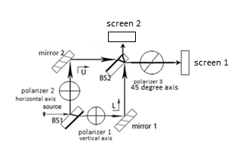

- A) Consider the following conversation between two students:
- Student 3: In the figure above, even if the source emits unpolarized photons, polarizer 3 will erase the “which-path” information.
- Student 4: I disagree. If the source emits unpolarized photons, we can consider half of the photons emitted to be vertically polarized and half of the photons emitted to be horizontally polarized. Approximately $N/4$ vertically polarized photons are absorbed by the horizontal polarizer and the other $N/4$ vertically polarized photons go through the L path. Therefore, even if these photons go through polarizer 3, we have “which-path” information for them and they will not show interference.
- Student 3: I see. In the same manner, $N/4$ horizontally polarized photons are absorbed by the vertical polarizer and the other $N/4$ horizontally polarized photons go through the U path. Therefore, we have “which-path” information for each photon, even if it goes through polarizer 3.
  - Student 4: However, if the source emits +45° polarized photons, the photons exiting beam splitter 2 are in a superposition state of upper and lower paths and also a superposition of horizontal and vertical polarizations, $\frac{\left|L\right.〉\left|H\right.〉+\left|L\right.〉\left|V\right.〉+\left|U\right.〉\left|H\right.〉-\left|U\right.〉\left|V\right.〉}{2\sqrt{2}}$. Since the phase difference from the two paths is such that constructive interference takes place at polarizer 3, the polarization state of the photon entering polarizer 3 in the lower path is $\left|45°\right.〉=\frac{\left|H\right.〉+\left|V\right.〉}{\sqrt{2}}$, and all photons will pass through polarizer 3. We would observe interference on the screen shown in the figure above.
  - Student 3: So polarizer 3 helps us to tell the difference between a source emitting unpolarized photons and a source emitting polarized photons.
Do you agree with Student 3 and Student 4? Explain your reasoning.

45. B) Consider the following conversation between two students about +45° polarized single photons emitted from the source:
  - Student 1: How do we know that inserting polarizer 3 (see figure above) erases “which-path” information? If all of the photons which enter polarizer 3 have a polarization state of $\left|45°\right.〉=\frac{\left|H\right.〉+\left|V\right.〉}{\sqrt{2}}$ because there is no phase difference from the two paths for the given setup, all of the photons entering polarizer 3 pass through it and constructively interfere at screen 1. So how can polarizer 3 erase “which-path” information?
  - Student 2: Think about it this way: If polarizer 3 is not present, even if we insert a phase shifter (e.g., a piece of glass) into one of the paths of the MZI (and change its thickness gradually), we would not observe interference because we have “which-path” information about the photons arriving at the screens. However, if polarizer 3 is present and we insert a phase shifter into one of the paths of the MZI and change its thickness gradually, we would observe changes in the interference pattern at screen 1 and the probability of a photon arriving there would change accordingly. Thus, polarizer 3 erases “which-path” information and we would observe intermediate interference. Because the original MZI setup is such that there is completely constructive interference at screen 1, the components of the photon state at polarizer 3 from the two paths arrive in phase in a state which is $\left|45°\right.〉=\frac{\left|H\right.〉+\left|V\right.〉}{\sqrt{2}}$, so all of the photons pass through polarizer 3 and we observe completely constructive interference. Thus, in the MZI setup shown above, polarizer 3 is indeed a quantum eraser and we will observe interference at screen 1, with or without a phase shifter present.
Polarizer 1 with a vertical polarization axis in L path and polarizer 2 with a horizontal axis in U path | Polarizer 3 (with a +45° polarization axis) is present | Polarizer 3 (with a +45° polarization axis) is not present
Phase shifter not present | MZI setup is a quantum eraser.  Constructive interference at screen 1. No interference displayed at screen 2. | MZI setup is NOT a quantum eraser.  No interference displayed at screen 1 or screen 2.
Phase shifter, e.g, glass piece, is present and the phase difference between the photon state from the two paths is varied by changing the thickness of the glass piece | MZI setup is a quantum eraser.  Interference pattern observed at screen 1 which changes based upon the phase difference introduced by the phase shifter. No interference at screen 2. | MZI setup is NOT a quantum eraser.  No interference displayed at screen 1 or screen 2.
Do you agree with Student 2’s explanation?

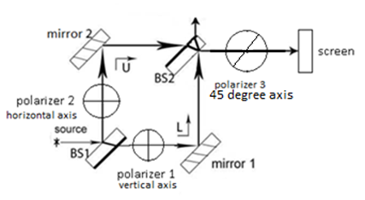

- For a source emitting +45° polarized photons, what would you observe at the screen shown above if polarizer 3 instead had a -45° polarization axis?
- No photons would reach the screen.
- The photons would still display interference because polarizer 3 still acts like a quantum eraser.
- The interference pattern would still be observed, but it would become dimmer due to decreased contrast.
- None of the above.

- For a source emitting 45° polarized photons when polarizers 1 and 2 have horizontal and vertical polarization axes and polarizer 3 has a +45° polarization axis, the setup is called a “quantum eraser”. Discuss with a partner why it should be called a “quantum eraser” and explain your reasoning.

- For a source emitting 45° polarized photons and when polarizers 1 and 2 have horizontal and vertical polarization axes and polarizer 3 has a +45° polarization axis, the setup is called a “quantum eraser”. Is this the only situation where polarizer 3 acts as a “quantum eraser”? If not, use the simulation to find another setup in which polarizer 3 can “erase” the “which-path” information. Discuss your result with a partner and explain your reasoning.

- A. In the situation for which polarizers 1 and 2 are orthogonal and the source emits 45° polarized photons, for which polarization axes does polarizer 3 create a “quantum eraser” setup? Discuss your answers with a partner and check your answers using the simulation. Explain your results.

49. B. Create a quantum eraser setup with a single photon source emitting a large number of vertically polarized photons.

- Create your own MZI experiment using the polarizers with different polarization axes. Have a partner predict what will appear on the screen and discuss your results. For each of the cases you come up with, discuss if the setup can be called a “quantum eraser.”

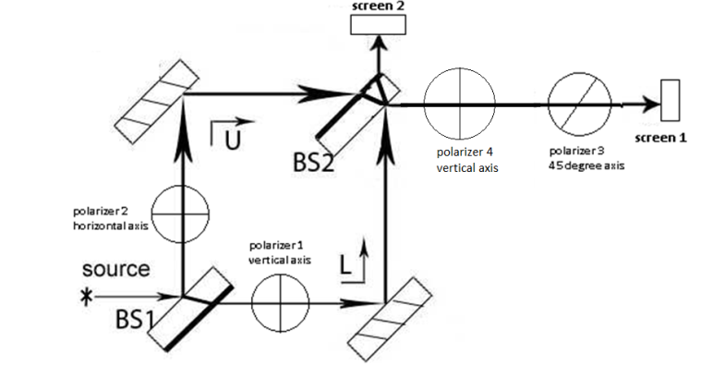

- Consider placing an additional polarizer 4 with a horizontal polarization axis in the MZI as shown in the figure above. The source emits 45° polarized photons.
- Will you have “which-path” information about any of the photons arriving at screen 1? Explain your reasoning.

- Consider the following conversation between Student A and Student B about the setup shown above:
  - Student A: We will not have “which-path” information about any of the photons arriving at screen 1 because polarizer 3 “erases” the “which-path” information. This MZI setup is indeed a quantum eraser.
  - Student B: I disagree with you. Polarizer 4 only allows vertically polarized light to pass through. The photons that exit polarizer 4 must have come from the lower path. Thus, we have “which-path” information about the vertically polarized photons that make their way to polarizer 3 and then arrive at screen 1.
  - Student A: But why doesn’t polarizer 3 “erase” the “which-path” information?
  - Student B: We have “which-path” information about the vertically polarized photons that exit polarizer 4. Polarizer 4 involves a measurement and collapses the state such that only vertically polarized photons pass through polarizer 4. Once the vertically polarized photon exits polarizer 4, it has a 50% probability of passing through polarizer 3 and a 50% probability of getting absorbed. Thus, only half of the horizontally polarized photons which exit polarizer 4 will pass through polarizer 3. However, we still have “which-path” information about all of those photons arriving at the screen (since it is the component of the photon state from the lower path L), and we will not observe an interference pattern on screen 1.
With whom do you agree? Explain your reasoning.

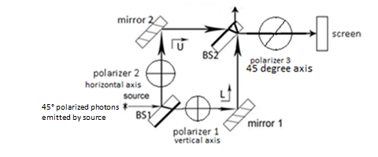

Quantum Eraser NOT a Quantum Eraser

Summary: Case 4-Quantum Eraser (Note: Quantum eraser only works if the photon source emits polarized photons)
For 45° polarized single photons emitted from the source:
- In order for polarizer 3 to erase “which-path” information, the source must emit polarized photons.
- If polarizer 3 with a 45° polarization axis is inserted between BS2 and the screen along with orthogonal polarizers 1 and 2 (with vertical and horizontal polarization axes, respectively) in the U and L paths, an interference pattern can be observed on the screen if polarizer 3 “erases” the “which-path” information.
- The polarization axis of polarizer 3 must be different than the polarization axes of the orthogonal polarizers in the two paths in order for the setup to be a “quantum eraser.”
- In the “quantum eraser” setup:
    - The “which-path” information (at the point detector or on the planar screen at the end) can be erased by polarizer 3 inserted between BS2 and the screen.
    - A single photon can interfere with itself in that case and interference will be observed on the planar screen or at the point detector (unlike the case with only two orthogonal polarizers in the U and L paths (as shown in the above right figure) when no interference is observed because we have “which-path” information for all photons.

$N$ unpolarized photons emitted | Highly collimated beam of photons (ignore the width of transverse Gaussian profile of the photon) |  | Photon with Transverse Gaussian profile (simulation setup)
Original MZI set up
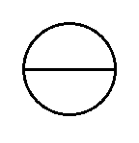  Horizontal polarizer in L path | Interference?  Yes. $N/2$ horizontally polarized photons at D1 show interference. | Summary of photons that show no interference?  $N/4$ vertically polarized photons are absorbed by horizontal polarizer in the L path.  “Which-path” info for $N/4$vertically polarized photons in the U path. Therefore, $N/8$of them arrive at D1 and $N/8$ of them arrive at D2. | Interference pattern?  Yes. Some photons that arrive at the screen show interference.
Horizontal polarizer In L path  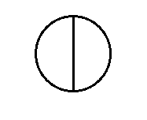vertical polarizer in U path | Interference?  No. | Summary of photons that show no interference?  $N/4$ vertically polarized photons are absorbed by horizontal polarizer in the L path and $N/4$ horizontally polarized photons are absorbed by the vertical polarizer in the U path.  “Which-path” info for $N/4$ horizontally polarized photons in the U path and $N/4$ vertically polarized photon in the L path. $N/8$ horizontally polarized photons and $N/8$ vertically polarized photons arrive at each detector D1 and D2. | Interference pattern?  No.
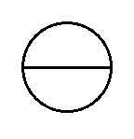Horizontal polarizer in L path  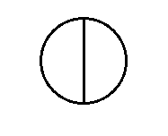Vertical polarizer in U path  45° polarizer before D1 or detecting screen | Interference?  No. | Summary of photons that show no interference?  $N/4$ vertically polarized photons are absorbed by horizontal polarizer in the L path and $N/4$ horizontally polarized photons are absorbed by the vertical polarizer in the U path.  “Which-path” info for $N/4$ horizontally polarized photons in the U path, $N/4$ vertically polarized photons in the L path. $N/16$ horizontally polarized photons and $N/16$ vertically polarized photons arrive at D1. The other $N/16$ horizontally polarized photons and $N/16$ vertically polarized photons are absorbed by the 45° polarizer before D1. $N/8$ horizontally polarized photons and $N/8$ vertically polarized photons arrive at D2. | Interference pattern?  No.

$N$ 45° polarized photons emitted | Highly collimated beam of photons (ignore the width of the transverse Gaussian profile of the photon) |  | Photon with a transverse Gaussian profile (simulation setup)
Original MZI set up
Horizontal polarizer in L path | Interference?  Yes. $N/2$ photons with a horizontal component of polarization arrive at D1. | Summary of photons that show no interference?  $N/4$ photons are absorbed by horizontal polarizer in L path.  “Which-path” info for $N/2$ photons with a vertical component of polarization. Therefore, $N/4$ of these photons arrive at D1 and $N/4$ of these photons arrive at D2. | Interference pattern?  Yes. Some photons that arrive at the detecting screen show interference.
Horizontal polarizer in L path  Vertical polarizer in U path | Interference?  No. | Summary of photons that show no interference?  $N/4$ photons are absorbed by horizontal polarizer in the L path and $N/4$ photons are absorbed by the vertical polarizer in the U path.  “Which-path” info for $N/4$ horizontally polarized photons in the L path and $N/4$ vertically polarized photons in the U path. Therefore, $N/8$ horizontally polarized photons and $N/8$ vertically polarized photons arrive at each detector D1 and D2. | Interference pattern?  No.
Horizontal polarizer in L path  Vertical polarizer in U path  45° polarizer before D1 or detecting screen 1 | Interference?  Yes. $N/4$  45° polarized photons arrive at detector D1. | Summary of photons that show no Interference?  $N/4$ photons are absorbed by horizontal polarizer in the L path and$N/4$photons are absorbed by the vertical polarizer in the U path.  “Which-path” info for $N/4$ photons that arrive at D2. | Interference pattern?  Yes. Quantum eraser setup recovers interference pattern.
$N$ vertically polarized photons emitted | Highly collimated beam of photons (ignore the width of the transverse Gaussian profile of the photon) |  | Photon with a transverse Gaussian profile (simulation setup)
Original MZI set up
45° polarizer in L path | Interference?  Yes. $N/2$ photons with a +45° component of polarization arrive at D1 and show interference. | Summary of photons that show no interference?  $N/4$ photons are absorbed by 45° polarizer in L path.  “Which-path” info for $N/2$ photons with a  -45°component of polarization. Therefore, $N/4$ of these photons arrive at D1 and $N/4$ of these photons arrive at D2. | Interference pattern?  Yes. Some photons that arrive at the detecting screen show interference.
45° polarizer in L path  -45° polarizer in U path | Interference?  No. | Summary of photons that show no interference?  $N/4$ photons are absorbed by 45° polarizer in L path and $N/4$ photons are absorbed by the -45° polarizer in U path  “Which-path” info for $N/4$ photons (45° polarized) in the L path and $N/4$ photons (-45° polarized) in the U path. Therefore, $N/8$ photons (45° polarized) and $N/8$ photons (-45° polarized) arrive at each detector D1 and D2. | Interference pattern?  No.
45° polarizer in L path  -45° polarizer in U path  Vertical polarizer before D1 or detecting screen 1 | Interference?  Yes. $N/4$ vertically polarized photons arrive at detector D1 and show interference. | Summary of photons that show no Interference?  $N/4$ photons are absorbed by the 45° polarizer in the L path and$N/4$photons are absorbed by the -45° in the U path.  “Which-path” info for $N/4$ photons that arrive at D2. | Interference pattern?  Yes. Quantum eraser setup recovers interference pattern.
To summarize your single photon results with MZI setup after a large number of photons ($N$) have been emitted from the source, fill out the following table. Assume that the source emits a beam of highly collimated photons (width of the Gaussian profile can be ignored) one at a time and the photons are 45° polarized.
Polarizer in  L path | Polarizer in U path | Polarizer between BS2 and detector 1 | Do you have “which-path” information for some or all photons arriving at the detectors?  - If for some photons: For approximately what fraction of photons and for which polarization, do we NOT have “which-path” information?  - If for all photons: Write “all” and explain.  - If no: Write “no” and explain. | Do any of the photons arriving at the detector 1 show interference? | Is the setup a “Quantum eraser”?
 | NO | NO
NO |  | NO
No |  | NO
 |  | NO
 |  | NO
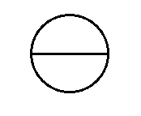
To summarize your single photon results with MZI setup after a large number of photons ($N$) have been emitted from the source, fill out the following table. Assume that the source emits a beam of highly collimated photons (width of the Gaussian profile can be ignored) one at a time and the photons are vertically polarized.
Polarizer in  L path | Polarizer in U path | Polarizer between BS2 and detector 1 | Do you have “which-path” information for some or all photons arriving at the detectors?  - If for some photons: For approximately what fraction of photons and for which polarization, do we NOT have “which-path” information?  - If for all photons: Write “all” and explain.  - If no: Write “no” and explain. | Do any of the photons arriving at the detector 1 show interference? | Is the setup a “Quantum eraser”?
 | NO | NO
NO |  | NO
NO |  | NO
 |  | NO
 |  | NO

Answers to multiple choice questions
1A. C
2A. B
3A. B, C
4A. B, C
5A. B
6. student 3
7A. yes
8. A
9. C
10. Student B, C
11A. D
11B. agree with Student B
12. D
13. Student 2
14A. A
15A. B
17A. agree with Student B
18A. student D
19A. B
20A. B
20C. Student B
21A. D
22A. 50%
22B. 25%
22C. 25%
22D. 25%
22E. agree with student B
23. agree with student 1 and 2
24A. D
25A. C
25C. agree with student D and E
26. agree with student A and B
27A. agree with student B and C
28A. C
29A. B
29C. agree with student A
29D. agree with student A and B
30A. B
31. agree with student A and B
32A. B
33A. D
34. agree with student 2
35A. B
36A. B
37. C
38. agree with student 1 and 2
39. A
40. A
41. B
42A. C
42C. agree with student B
43A. agree with student 2
45B. agree with student 2
46. A
51B. agree with student B

