Mach-Zehnder Interferometer (MZI) Warm-Up

The setup for the ideal Mach-Zehnder interferometer (MZI) shown below is as follows:
- All angles of incidence are 45° with respect to the normal to the surface.
- For simplicity, we will assume that a photon can only reflect from one of the two surfaces of the identical half-silvered mirrors (beam splitters) BS1 and BS2 because of anti-reflection coatings.
- The detectors D1 and D2 are point detectors located symmetrically with respect to the other components of the MZI as shown.
- The photons originate from a monochromatic coherent point source. (Note: Experimentally, a source can only emit nearly monochromatic photons such that there is a very small range of wavelengths coming from the source. Here, we assume that the photons have negligible “spread” in energy.)
- Assume that the photons propagating through both the U and L paths travel the same distance in vacuum to reach each detector.
- In the classical usage of the Mach-Zehnder Interferometer, a “beam” of light is sent which gets separated spatially after passing through BS1. Now, we will send one photon at a time through the MZI.
- In all of the discussions below, ignore the effect of polarization of the photons due to reflection by the beam splitters or mirrors.
- Assume that the photons coming from the single photon source are unpolarized.
- Assume that beam splitters BS1 and BS2 are infinitesimally thin so that there is no phase shift when a photon propagates through them.
- For the entire tutorial, assume that a large number (N) of photons are sent one at a time.
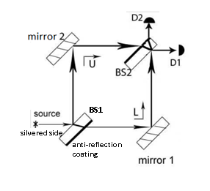

The goal of this warm-up is to review interference at the detectors due to the superposition of light from two paths of the MZI
  - Rope analogy for understanding phase shifts in various cases
  - Phase shifts due to reflection and transmission at the interface of media with different indices of refraction
  - Phase shift for propagation through a medium

- Which one of the following is true about the half-silvered mirrors (ideal beam splitters)?
  - They completely reflect the light falling on them.
  - They completely absorb the light falling on them.
  - Roughly half of the light incident onto them is reflected and half of it is transmitted.
  - Roughly half of the light incident onto them is absorbed and half of it is transmitted.

- Assuming that the speed of light at a specific wavelength in a certain type of glass is 2/3 of the speed of light in vacuum, which one of the following is the refractive index n of glass?
  - $n = 2/3$
  - $n = 3/2$
  - $n = 1$
  - There is not enough information.

- Before we discuss whether a phase shift is introduced by the reflection or transmission of light (electromagnetic wave) at the interface between two media (e.g., at the air-glass interface in the beam splitters BS1 and BS2), let's review analogous concepts for a pulse propagating on a rope:

- A rope has a fixed end because it is tied to a pillar at that end. You hold the other end and give the rope a sudden jerk to produce a pulse. The pulse travels towards the fixed end and reflects back. Which of the following is true for the reflected pulse due to reflection at the fixed end?
  - It is inverted.
  - It is upright (not inverted).
  - There is no reflected pulse.
  - None of the above.

- A rope has a free end with a ring inserted into a pillar so that the ring can freely move up and down the pillar. You hold the other end and give the rope a sudden jerk to produce a pulse. The pulse travels towards the free end and reflects back. Which of the following is true for the reflected pulse due to reflection at the free end?

  - It is inverted.
  - It is upright (not inverted)
  - There is no reflected pulse.
  - None of the above.

- In the following three questions, we relax the constraints of a completely fixed or free boundary condition and consider the reflection and transmission at the interface of two ropes with different linear mass densities (mass per unit length). A very long rope consists of two parts: one half of the rope has a lower linear mass density ρ_{L} and the other half has a higher linear mass density ρ_{H}. You hold the end of the rope with mass density ρ_{L} and your friend holds the end of the rope with ρ_{H.}

- You give the rope a sudden jerk to produce a pulse in the lower density rope. The pulse travels towards your friend and partly gets reflected back at the interface where the ropes are joined. Which one of the following phase shifts is introduced in the reflected pulse due to the reflection at the interface?
(Hint: Think about whether this case is qualitatively similar to the fixed or free boundary condition cases discussed earlier.)

- zero
- π/2
- π
- None of the above.

- The reflected pulse is inverted and in terms of sinusoidal waves that inversion corresponds to a phase change of π.

- You give the rope a sudden jerk to produce a pulse in the lower density rope. The pulse travels towards your friend and partly gets transmitted to the higher density rope. Which one of the following phase shifts is introduced in the transmitted pulse at the interface?
(Hint: Think about whether there can be any discontinuity in the wave profile as it gets transmitted at the interface.)

- zero
- π/2
- π
- None of the above.

- The transmitted pulse is upright (not inverted) and in terms of sinusoidal waves this corresponds to a phase shift of zero.

- Your friend gives the rope a sudden jerk to produce a pulse in the higher density rope. The pulse travels towards you and partly gets reflected back at the interface where the ropes are joined. Which one of the following phase shifts is introduced in the reflected pulse due to the reflection at the interface?
(Hint: Think about whether this case is qualitatively similar to the fixed or free boundary condition)

- zero
- π/2
- π
- None of the above.

- The reflected pulse is upright (not inverted) and in terms of sinusoidal waves this corresponds to a phase shift of zero.
- We can see a parallel between the mass density of a rope and the refractive index of a medium. Lower mass density is analogous to lower refractive index and higher mass density is analogous to higher refractive index. We can use this analogy to calculate the phase shift (change in phase) of light introduced by reflection or transmission at the interface between two media. We will also discuss the propagation of light through a refractive medium.

- Light (plane harmonic electromagnetic wave) is incident from air onto a glass surface. The light gets partially reflected back into the air after striking the air-glass interface. Which one of the following phase shifts is introduced in the reflected light due to the reflection at the interface? Always assume that the angle of incidence is smaller than the Brewster's angle.
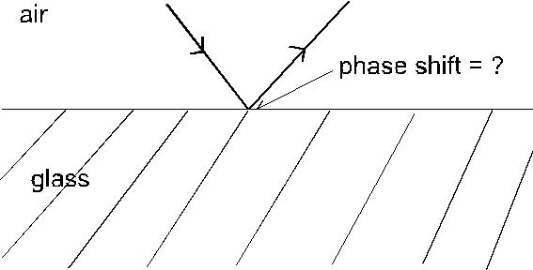

- zero
- π/2
- π
- None of the above.

- Light initially traveling in a medium with a lower refractive index (e.g., air) undergoes a phase shift of π at the interface when it gets reflected from an interface with a medium having a higher refractive index.

- Light is incident from air onto a smooth glass surface. The light is partially transmitted into the glass after striking the air-glass interface. Which one of the following phase shifts is introduced in the transmitted light due to the interface?
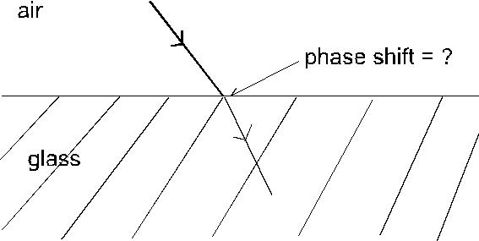

- zero
- π/2
- π
- None of the above.

- Transmission of light at an interface between two media does not cause a phase shift.

- Light traveling in glass encounters a glass-air interface. The light that gets reflected back into glass after striking the glass-air interface will undergo which one of the following phase shifts at the interface of the two media?
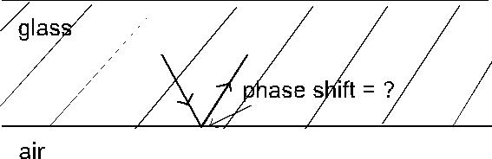

- zero
- π/2
- π
- None of the above.

- Light initially traveling in a medium with a higher refractive index (e.g., glass) undergoes no phase shift at the interface when it gets reflected from an interface with a medium having a lower refractive index.

- A glass plate (a refractive medium) is introduced into the path of light traveling from point A to point B. Which one of the following statements is true about the phase shift of light between points A and B due to its propagation in the refractive medium?
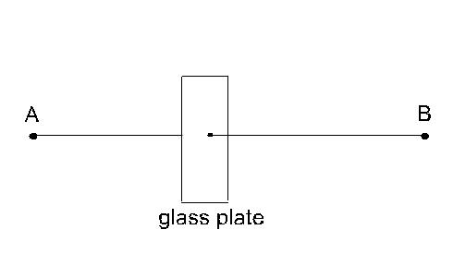

- There is no phase shift.
- There is a phase shift depending on the refractive index of glass only.
- There is a phase shift depending on the thickness of the glass only.
- There is a phase shift depending on both the refractive index and the thickness of the glass.

- Light propagating through a refractive medium such as glass undergoes a phase shift depending on the refractive index and the thickness of the glass plate.

Table 1: Summary of above responses to questions 8-11

 | Initially in medium with lower n | Initially in medium with higher n
Reflection at interface | Phase shift of π | No phase shift
Transmission at interface | No phase shift | No phase shift
Propagation through a medium | Phase shift depending on thickness and refractive index n

- Choose all of the following statements that are correct:

- Interference of light manifests the wave nature of light.
- Interference of light at a point requires that two or more light waves meet at that point at the same time.
- Interference can be completely constructive, completely destructive, or intermediate depending on the relative phase difference of the light waves from different paths.
- (I) and (II) only
- (I) and (III) only
- (II) and (III) only
- All of the above.

Let's focus on the MZI now:
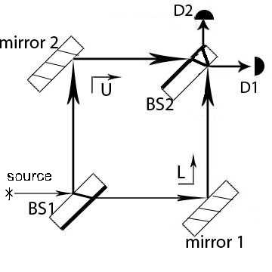

Note: In this tutorial, we will assume that the light propagating through both the U and L paths travels the same distance in vacuum to reach each detector. Therefore, there is no relative phase difference introduced between the beams from the U and L paths due to the propagation in vacuum. The phase shift due to propagation through a vacuum (which is the same along both the U and L paths) is Φ_{v}. We will also assume that the beam splitters BS1 and BS2 are so thin that no phase shift is introduced due to the propagation of light through them.

Look at the apparatus carefully and answer the following questions.

- Based upon Table 1, what is the total phase shift of light through path U (from the source to the detector) when it reaches detector D1? (Φ_{v} is the phase shift introduced by the propagation of light through vacuum. Each mirror introduces a phase shift of π. A phase shift of 2π is equivalent to a zero phase shift.)
  - Φ_{v}
  - Φ_{v} + π/2
  - Φ_{v} + π
  - None of the above.

- Based upon Table 1, what is the phase shift of light through path L (from the source to the detector) when it reaches detector D1? (Φ_{v} is the phase shift introduced by the propagation of light through vacuum. Each mirror introduces a phase shift of π. A phase shift of 2π is equivalent to a zero phase shift.)

- Φ_{v}
- Φ_{v} + π/2
- Φ_{v} + π
- None of the above.

- Based upon your responses to the last two questions, should you observe constructive or destructive interference at detector D1 due to the propagation of light through the two paths?

  - Constructive interference only
  - Destructive interference only
  - Sometimes constructive and sometimes destructive interference
  - There will not be any interference.

Note: Since each detector is a point detector, we only observe interference at a point due to the superposition of waves from the two paths. Therefore, we will use the phrase “interference at the detector” rather than using the phrase “interference pattern at the detector”. Later, when we replace point detectors with screens (which are planar detectors) we will observe an interference pattern in a region comparable to the width of the light beam. (Note: A narrow light beam can be thought of as having a Gaussian profile with a certain width.)

- Based upon Table 1, what is the phase shift of light through path U when it reaches detector D2? (Φ_{v} is the phase shift introduced by the propagation of light through vacuum. Each mirror introduces a phase shift of π. A phase shift of 2π is equivalent to a zero phase shift.)

- Φ_{v}
- Φ_{v} + π/2
- Φ_{v} + π
- None of the above.

- Based upon Table 1, what is the phase shift of light through path L when it reaches detector D2? (Φ_{v} is the phase shift introduced by the propagation of light through vacuum. Each mirror introduces a phase shift of π. A phase shift of 2π is equivalent to a zero phase shift.)

- Φ_{v}
- Φ_{v} + π/2
- Φ_{v} + π
- None of the above.

- Based upon your responses to the last two questions, should you observe constructive or destructive interference at detector D2 due to the propagation of light through the two paths?
  - Constructive interference only
  - Destructive interference only
  - Sometimes constructive and sometimes destructive interference
  - There will not be any interference.

- Choose all of the following statements that are true about the effect of introducing a thin glass plate in one of the two paths (U or L):
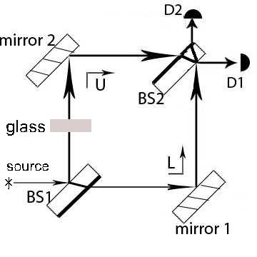

- The phase shift due to the plate in one of the paths can alter the phase relation between the beams reaching the detectors from the two paths.
- There will not necessarily be completely destructive interference at detector D2.
- Measuring the changes in the interference at detectors D1 and D2 can help one calculate the phase shift produced by the plate.

- (I) and (II) only
- (I) and (III) only
- (II) and (III) only
- All of the above.

Note: We can change the phase relation between the light from the two paths arriving at the detectors (e.g., by introducing glass plates with different thicknesses) and change the type of interference (e.g., constructive, destructive, intermediate etc.) produced at each detector.

