Pretest

In all questions, ignore relativistic effects.

For any constant, e.g., the mass of an electron or muon or Planck's constant, use the following values:
- 1 eV = 1.6 ×10⁻¹⁹ J
- keV = kilo electron volt = 10³ eV, meV = milli electron volt = 10⁻³ eV
- 1 mm = 10⁻³ m, 1 µm = 10⁻⁶ m, 1 nm = 10⁻⁹ m, 1 pm = 10⁻¹² m

- Planck's constant = h = 6.6 × 10⁻³⁴ Js
- magnitude of elementary charge (on an electron or proton) = e = 1.6 × 10⁻¹⁹ C
- speed of light = c = 3 × 10⁸ m/s

- mass of electron = 9.1 × 10⁻³¹ kg
- mass of neutron = mass of proton = 1.67 × 10⁻²⁷ kg
- mass of muon = 1.9 × 10⁻²⁸ kg
- mass of helium atom = 6.68 × 10⁻²⁷ kg
- mass of sodium atom = 3.8 × 10⁻²⁶ kg

Pretest

1. Is it possible for an electron of a given kinetic energy K to have a wavelength associated with it? Explain.

2. What is the de Broglie relation? In one or two sentences, explain its significance.

3. Consider the following conversation between two students about a double slit experiment in which a source of He atoms is so precise that it can emit one atom at a time toward the slits:
● Andy: Even if we send one He atom at a time from the source, we will observe an interference pattern on the screen after a large number of He atoms have arrived at the screen. Each He atom propagates as a wave. While passing through the slits, it splits into two waves, each with half the energy. These two waves, each with half the energy, interfere with each other.
● Caroline: I disagree. A He atom can pass through only one slit at a time. If what you are saying is true and the He atom is indeed delocalized and can pass through both slits simultaneously, we would see some sort of extended streak on the screen instead of a single flash for each He atom.

With whom, if either, do you agree?
(a) Andy
(b) Caroline
(c) Neither of them
Explain your reasoning.

4. You are conducting a double-slit experiment in which you send a large number of non-relativistic electrons of the same energy one at a time towards a double-slit plate. The slit width is 50 pm, the slit separation is 1 nm and the distance between the slits and the screen is 3 m.

(i) If the kinetic energy of each electron is 10 keV, what is its wavelength?

(ii) Describe the pattern you expect to observe on the screen after a large number of electrons have passed through. Explain your reasoning.

(iii) Suppose the experiment is now modified by decreasing the kinetic energy of the electrons, while keeping all other parameters the same (slit width, slit distance etc.) How does the pattern on the screen change, if at all?

(iv) Explain your reasoning for your answer in 4 (iii).

5. Suppose the experiment in problem 4 (i) (electrons of 20 keV kinetic energy, slit width 50 pm, slit separation 1 nm and screen 3 m away from the slits) is modified by using protons instead of electrons while all the other parameters mentioned (kinetic energy, slit width, slit separation etc.) are held fixed.
(i) How does the pattern on the screen change, if at all?

(ii) Explain your reasoning for your answer in 5 (i).

6. Suppose the experiment in problem 4 (i) (electrons of 20 keV kinetic energy, slit width 50 pm, slit separation 1 nm and screen 3 m away from the slits) is modified by replacing the electrons with protons keeping the wavelength of the protons the same as the wavelength of the electrons.
(i) How does the pattern on the screen change, if at all?

(ii) Explain your reasoning for your answer in 6 (i).

7. Consider a double slit experiment in which individual photons are sent one at a time towards a double slit. The photon source is coherent and emits photons with a fixed wavelength.
(i) What do you expect to observe on the screen after a large number of photons arrive at the screen?

(ii) Explain your reasoning for your answer in 7 (i).

8. Consider particles of sand, which can be approximated as spheres of a radius of about 1/10 of a millimeter.
(i) Do you expect that a double slit experiment with well-chosen parameters would show an interference pattern?

(ii) Explain your reasoning for your answer in 8 (i).

In questions 9-13, assume that particles are sent one at a time from the particle source. The figure below shows a double-slit experiment which was modified by adding a lamp (light bulb) between the double slit and the screen (slightly off to the side so it is not directly in front of the slits).
- Assume that when the lamp is turned on, if scattering occurs between a particle used in the double-slit experiment and a photon from the lamp, this scattering occurs at the slits only.
- Assume that ALL the particles scattered by photons still reach the screen.
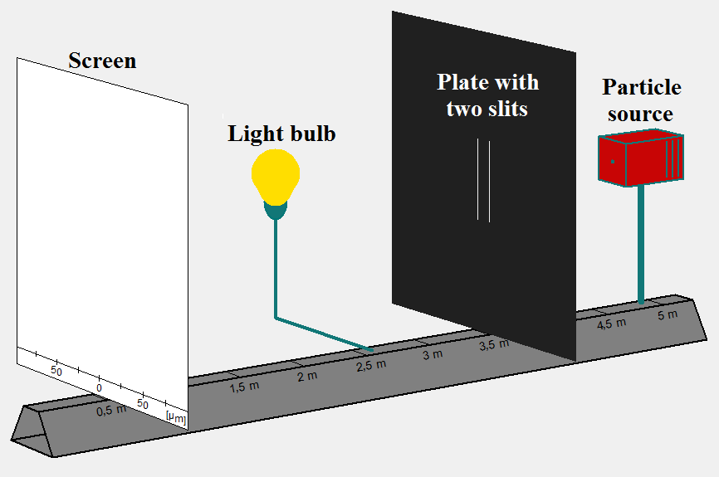
Fig. 1: Double slit set-up with the addition of a lamp.

9. Suppose you perform a double slit experiment with electrons while the lamp is turned off and observe an interference pattern on the screen. You then repeat the experiment with the lamp turned on (assume that the intensity of the lamp is such that every particle used in the experiment scatters off a photon).
(i) Describe a situation in which this addition of the lamp between the double slit and the screen destroys the interference pattern observed on the screen (in the situation you describe, assume that all particles reach the screen even if scattering occurs between the particles and the photons emitted by the lamp).

(ii) Explain your reasoning for your answer in 9 (i).

Question 10-13 refer to the following setup:
You perform a double-slit experiment using Na atoms and observe an interference pattern on the screen. You then change the experiment by adding a lamp as discussed earlier.
- If slit 2 is closed, the wave function of a Na atom that goes through slit 1 and arrives at a point x on the screen is $Ψ_{1}(x)$. If instead, slit 1 is closed, the wave function of a Na atom that goes through slit 2 and arrives at a point x on the screen is $Ψ_{2}(x)$.
- For this example, if slit 2 is closed, and a total number N of particles arrive at the screen, the number density of the particles at a point x on the screen is $N{\left|Ψ_{1}(x)\right|}^{2}$.
- For problems 11-14, both slits are open.

10. For (i) and (ii) below, suppose that the wavelength of the photons is significantly smaller than the distance between the slits and the intensity of the lamp is such that each Na atom scatters off a photon. Also, assume that all the scattered atoms still reach the screen.
(i) Write down an expression for the number density of Na atoms at a point x on the screen in terms of $Ψ_{1}(x)$ and $Ψ_{2}(x)$ after a large number N of Na atoms arrive at the screen.

(ii) Describe the pattern you expect to observe on the screen after a large number N of Na atoms have arrived at the screen. Explain your reasoning.

11. For (i) and (ii) below, suppose that the wavelength of the photons is significantly larger than the distance between the slits and the intensity of the lamp is such that each Na atom scatters off a photon. Also, assume that all scattered atoms still reach the screen.
(i) Write down an expression for the number density of Na atoms at a point x on the screen in terms of $Ψ_{1}(x)$ and $Ψ_{2}(x)$ after a large number N of Na atoms arrive at the screen.

(ii) Describe the pattern you expect to observe on the screen after a large number N of Na atoms have arrived at the screen. How, if at all, is this pattern different from the pattern in 10(ii)? Explain your reasoning.

For (i) and (ii) below, suppose that the wavelength of the photons is significantly smaller than the distance between the slits and the intensity of the lamp is such that about half of the Na atoms scatter off a photon. Also, both slits are open and all the atoms reach the screen, including the ones that scatter.
(i) Write down an expression for the number density of Na atoms at a point x on the screen in terms of $Ψ_{1}(x)$ and $Ψ_{2}(x)$ after a large number N of Na atoms arrive at the screen.

(ii) Describe the pattern you expect to observe on the screen after a large number N of Na atoms have arrived at the screen. How, if at all, is this pattern different from the pattern in 11(ii)? Explain your reasoning.

13 For (i) and (ii) below, suppose that the wavelength of the photons is significantly larger than the distance between the slits and the intensity of the lamp is such that about half of the Na atoms scatter off a photon. Also, both slits are open and all the atoms reach the screen, including the ones that scatter.
(i) Write down an expression for the number density of Na atoms at a point x on the screen in terms of $Ψ_{1}(x)$ and $Ψ_{2}(x)$ after a large number N of Na atoms arrive at the screen.

(ii) Describe the pattern you expect to observe on the screen after a large number N of Na atoms have arrived at the screen. How, if at all, is this pattern different from the pattern in 11(ii)? Explain your reasoning.

14. You perform a double slit-experiment in which unpolarized photons are sent one at a time towards the double slit. The wavelength of the photons is comparable to the width of the slits and the separation between the slits is more than twice the slit width. In all parts (i) through (vi) below, assume that the same large number N of photons reach the screen (in other words, you wait long enough in each case to clearly observe the pattern that forms on the screen).
(i) Describe the pattern you expect to observe on the screen after a large number N of photons reach the screen. Explain your reasoning.

(ii) Suppose that a vertical polarizer is placed in front of only one of the slits. Describe the pattern you expect to observe on the screen after a large number N of photons reach the screen. How does this pattern differ, if at all, from the pattern observed in 14(i)? Explain your reasoning.

(iii) Suppose that a vertical polarizer is placed in front of each of the two slits. Describe the pattern you expect to observe on the screen after a large number N of photons reach the screen. How does this pattern differ, if at all, from the pattern observed in 14(i)? Explain your reasoning.

(iv) Explain the difference between the situations described in 14 (ii) and 14 (iii), namely, one polarizer placed in front of one slit only and one polarizer placed in front of each of the two slits.

(v) Suppose that a vertical polarizer is placed in front of one of the slits and a horizontal polarizer is placed in front of the other slit. Describe the pattern you expect to observe on the screen after a large number N of photons reach the screen. How does this pattern differ, if at all, from the pattern observed in 14(i)? Explain your reasoning.

(vi) Suppose that a vertical polarizer is placed in front of one of the slits and a horizontal polarizer is placed in front of the other slit. Furthermore, an additional polarizer which makes an angle of 45° with the horizontal is placed right before the screen. Describe the pattern you expect to observe on the screen after a large number N of photons reach the screen. How does this pattern differ, if at all, from the pattern observed in 14(i)? Explain.

