Mach-Zehnder Interferometer (MZI): Pre-test

The setup for the ideal Mach-Zehnder interferometer (MZI) is as follows:
- All angles of incidence are 45° with respect to the normal to the surface.
- For simplicity, we will assume that a photon can only reflect from one of the two surfaces of the identical half-silvered mirrors (beam splitters) BS1 and BS2 because of anti-reflection coatings.
- The photo-detectors D1 and D2 are point detectors located symmetrically with respect to the other components of the MZI as shown.
- The photons originate from a monochromatic coherent point source. (Note: Experimentally, a source can emit a nearly monochromatic beam, so there is a very small range of wavelengths coming from the source. Thus, the beam has a very narrow “spread” in energy.)
- Assume that the photons propagating through both the U and L paths travel the same distance in vacuum to reach each detector.
- In all of the discussions below, ignore the effect of polarization of the photons due to reflection by the beam splitters or mirrors.
- Beam splitters BS1 and BS2 are infinitesimally thin so that there is no phase shift when a single photon propagates through them.
- The MZI set up is such that there is completely constructive interference at D1 and completely destructive interference at D2.

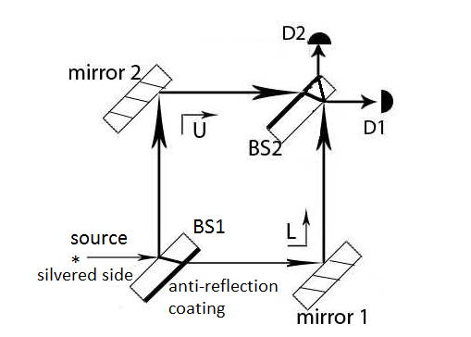

Figure 1

For questions all of the following questions, assume that:
- The photons are emitted from the source in a highly collimated beam, i.e., the width of the transverse Gaussian profile of each photon is negligible.
- A very large number ($N$) of single photons are sent from the source one at a time through beam splitter BS1.

Figure 1

- Consider the following statement from Student A:

- If the source emits $N$ photons one at a time, the number of photons reaching detectors D1 and D2 will be $N/2$ each.

Explain why you agree or disagree with Student A.

- Consider the following conversation between Student 1 and Student 2:

- Student 1: The beam splitter BS1 causes the photon to split in two parts and the energy of the incoming photon is also split in half. Each photon with half of the energy of the incoming photon travels along the U and L paths of the MZI and produces interference at detectors D1 and D2.
- Student 2: If we send one photon at a time through the MZI, there is no way to observe interference in the detectors D1 and D2. Interference is due to the superposition of waves from the U and L paths. A single photon must choose either the U or the L path.
Do you agree with Student 1 or Student 2? Explain your reasoning for each case.

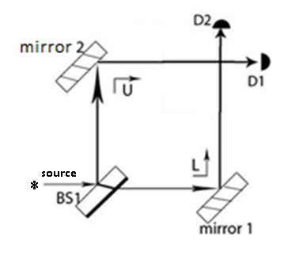
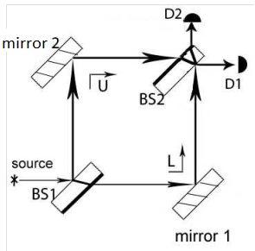

Figure 2
- Suppose we remove BS2 from the MZI setup as shown in Figure 2 above. How does the probability that detector D1 or D2 will register a photon in this case differ from the case when BS2 is present as in Figure 1? Explain your reasoning.

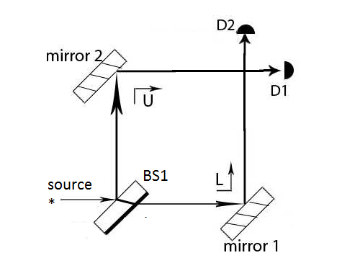

Figure 3

- Suppose we have an MZI setup initially without BS2. If we suddenly insert BS2 after the photon enters BS1 but before it reaches the point where BS2 is inserted (see Figure 3 above), with what probabilities do detectors D1 and D2 register the photon? Explain your reasoning. Assume that the situation after BS2 is inserted is identical to Figure 1.

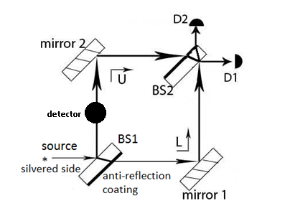

Figure 4
- Suppose we modify the set up shown in Figure 1 and insert a photo-detector into the upper path between mirror 2 and BS2 as shown in Figure 4.
- How does the what you observe at detectors D1 and D2 compare to the case in Figure 1 in which the photo-detector is not present in the upper path?

- If there is interference displayed by any photons at detector D1, write down the percentage of the photons emitted by the source that display interference. You must explain your reasoning.

For all of the following questions, assume that:
- The single photon source emits photons that are polarized at 45°.
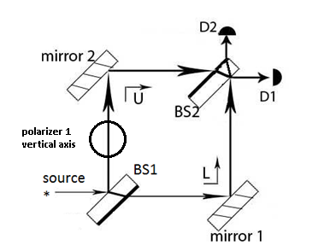

Figure 5
- You modify the set up shown in Figure 1 and insert a polarizer with a vertical polarization axis as shown in Figure 5.
- Describe in detail what you would observe at the detectors D1 and D2 and how this situation will differ from the case in Figure 1 in which there is no polarizer in path U.

- If there is interference displayed by any photons at detector D1, write down the percentage of the photons emitted by the source that display interference. You must explain your reasoning.

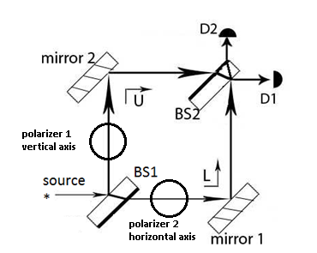

Figure 6

- You modify the set up shown in Figure 1 and insert polarizer 1 with a vertical polarization axis (between BS1 and mirror 2) and polarizer 2 with a horizontal polarization axis (between BS1 and mirror 1) in the U and L paths as shown in Figure 6.
- Describe in detail what you would observe at the detectors D1 and D2 and how this situation will differ from the case in Figure 5 in which only polarizer 1 was present (as in question 6). Explain your reasoning.

- If there is interference displayed by any photons at detector D1, write down the percentage of the photons emitted by the source that display interference. You must explain your reasoning.

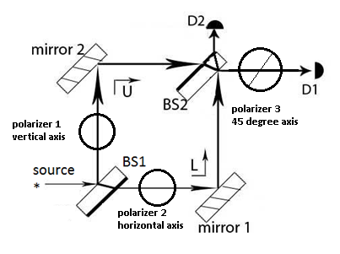

Figure 7

- You start with the set up shown in Figure 6 with polarizer 1 with a vertical polarization axis and polarizer 2 with a horizontal polarization axis inserted in the U and L paths, respectively. You modify the set up and insert polarizer 3 with a +45° polarization axis between BS2 and detector D1 (see Figure 7).
- Describe in detail what you would observe at the detectors D1 and D2 and how this situation will differ from the case in Figure 6 in which polarizer 3 was not present (as in question 7). Explain your reasoning.

- If there is interference displayed by any photons at detector D1, write down the percentage of the photons emitted by the source that display interference. You must explain your reasoning.

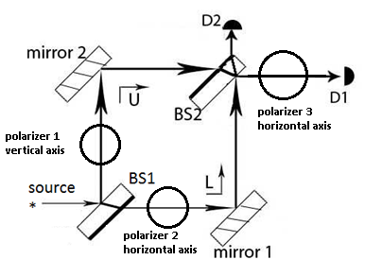

Figure 8

- You start with the set up shown in Figure 6 with polarizer 1 with a vertical polarization axis and polarizer 2 with a horizontal polarization axis inserted in the U and L paths, respectively. You modify the set up and insert polarizer 3 with a horizontal polarization axis between BS2 and the detector D1 (see Figure 8).
- Describe in detail what you would observe at the detectors D1 and D2 and how this situation will differ from the case in Figure 6 in which polarizer 3 was not present (as in question 7). Explain your reasoning.

- If there is interference displayed by any photons at detector D1, write down the percentage of the photons emitted by the source that display interference. You must explain your reasoning.

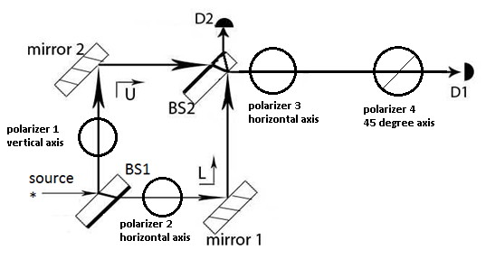

Figure 9
- You set up an MZI as shown in Figure 9, inserting polarizer 1 with a vertical polarization axis and polarizer 2 with a horizontal polarization axis in the U and L paths, respectively. You also insert polarizer 3 with a horizontal polarization axis and polarizer 4 with a 45° polarization axis between BS2 and detector D1 (see Figure 9).
- How does what you observe at the detectors compare with the situation in which polarizer 3 was not present?

- If there is interference displayed by any photons at detector D1, write down the percentage of the photons emitted by the source that display interference. You must explain your reasoning.

- Describe an experiment using a Mach-Zehnder Interferometer in which you could distinguish between a source emitting unpolarized and polarized photons.

